

ASSIGNMENT – 01

COURSE : DEVOPS

Trainer : Mr . MADHUKAR

NAME : V SHIVASAI

Mail id : SHIVASAINETHA313@GMAIL.COM

1 . Create a S3 bucket and enable cross region replication for any two buckets in different in different region ?

* Go to Amazon S3 , Click on Create Bucket

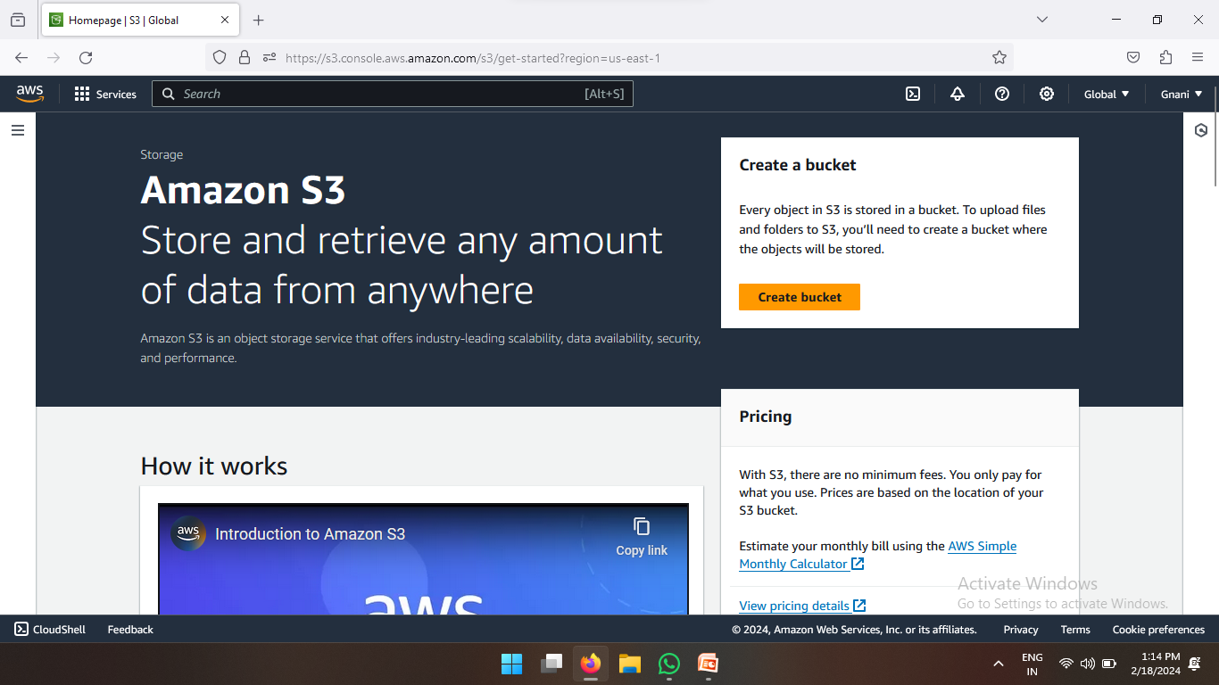

* Enter Bucket Name and Select Any one Region

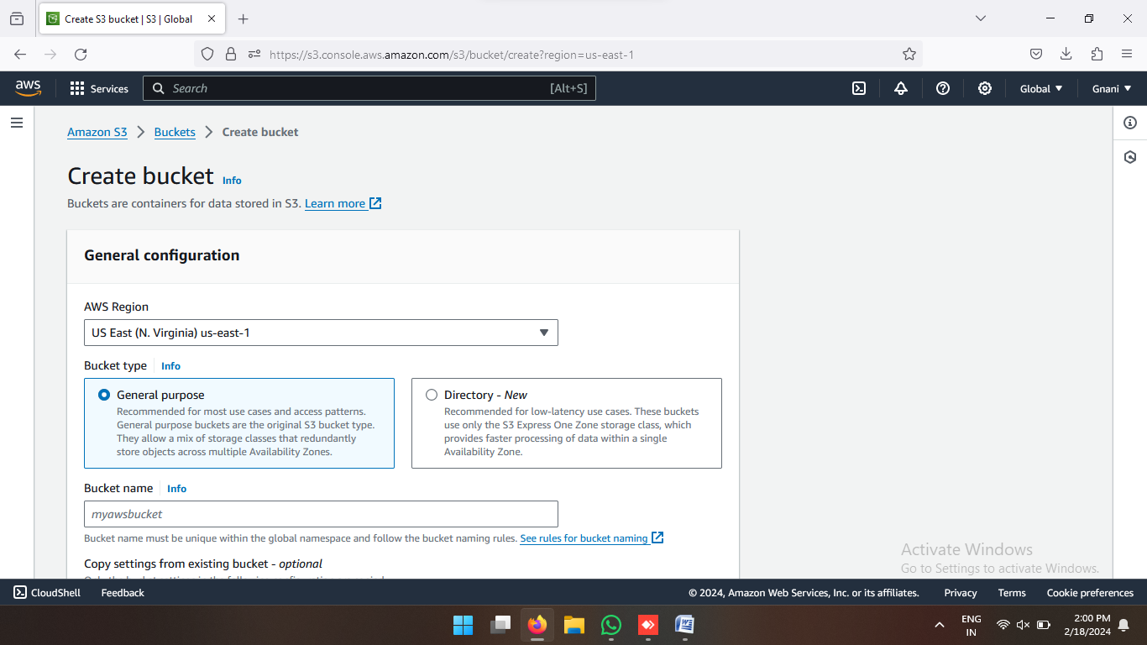

* Enable Bucket Version

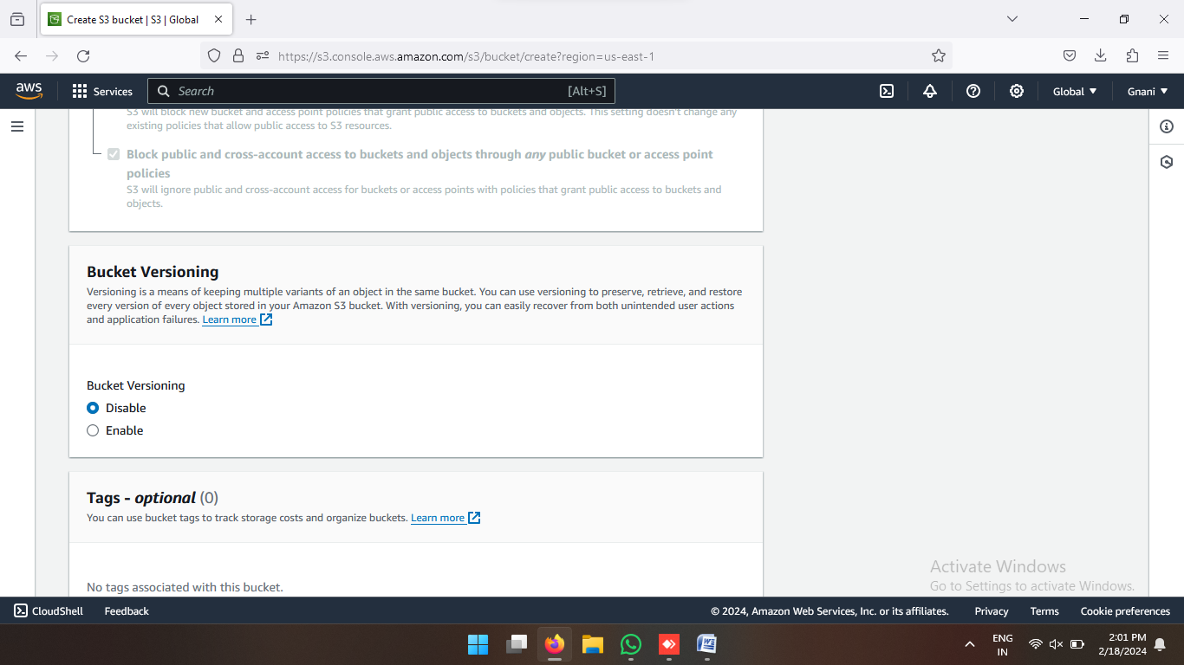

* After that Click on Create Bucket

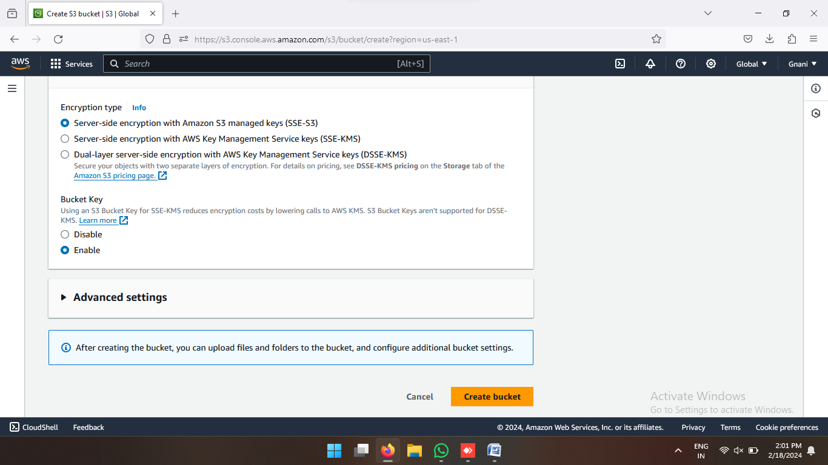

* One more bucket created in different region.

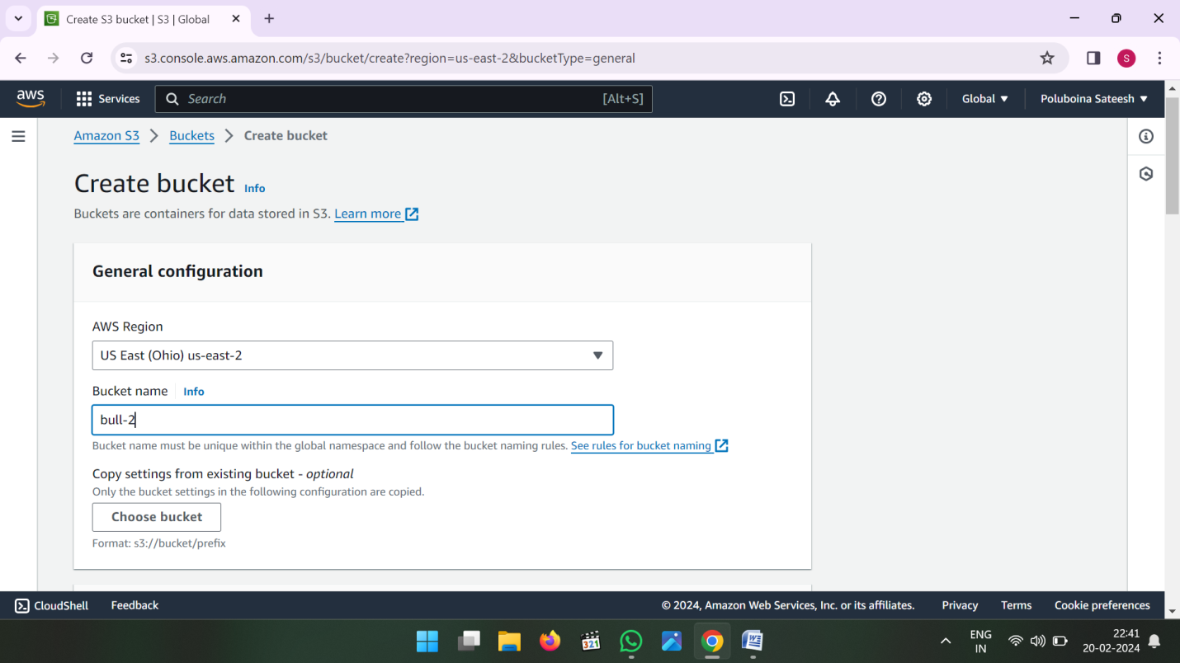

Now see the 2 Buckets in different region

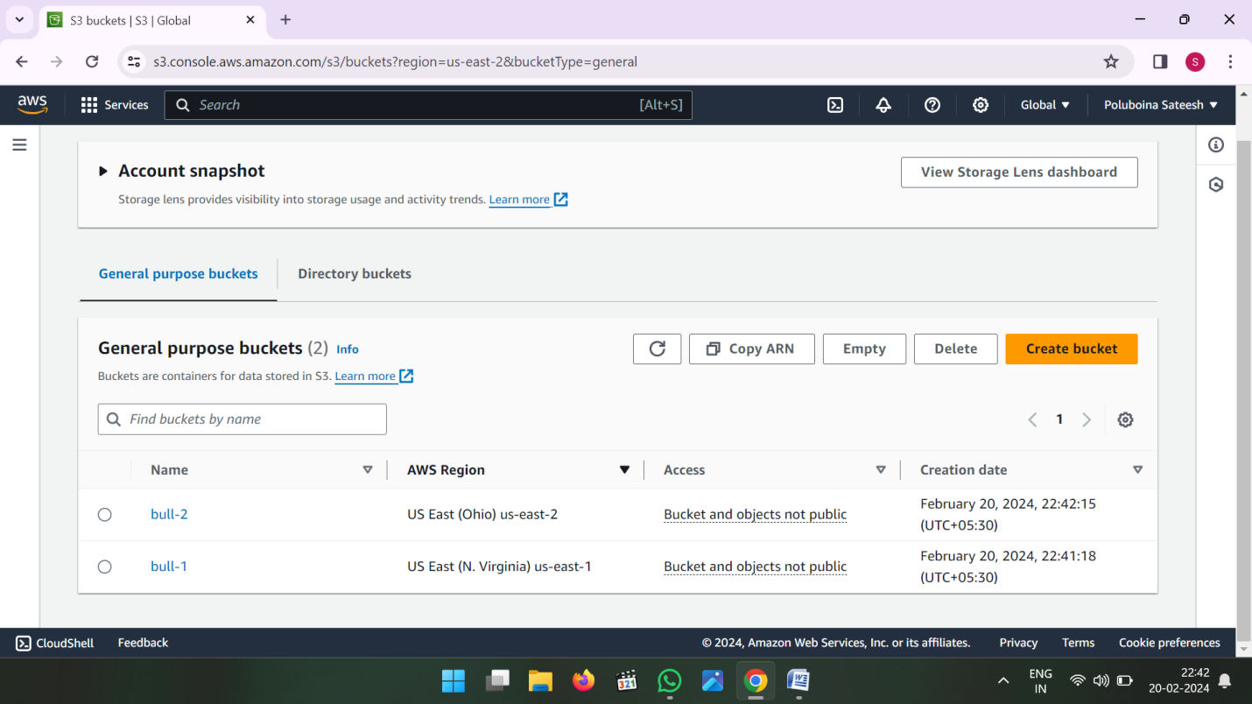

* Now go to first bucket and click on upload

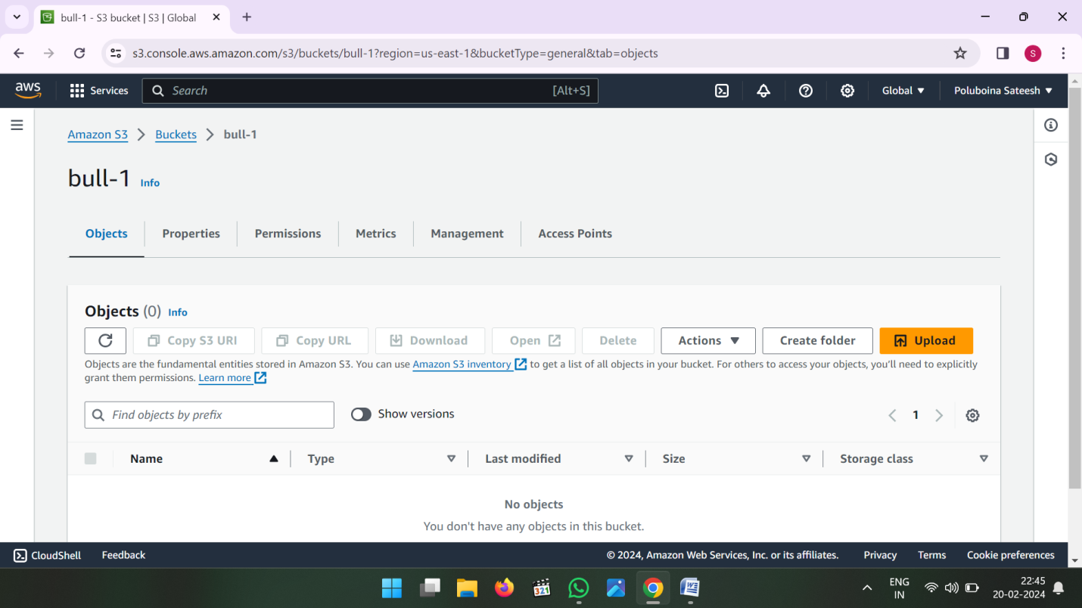

* Then Add Files and Add Folders then upload

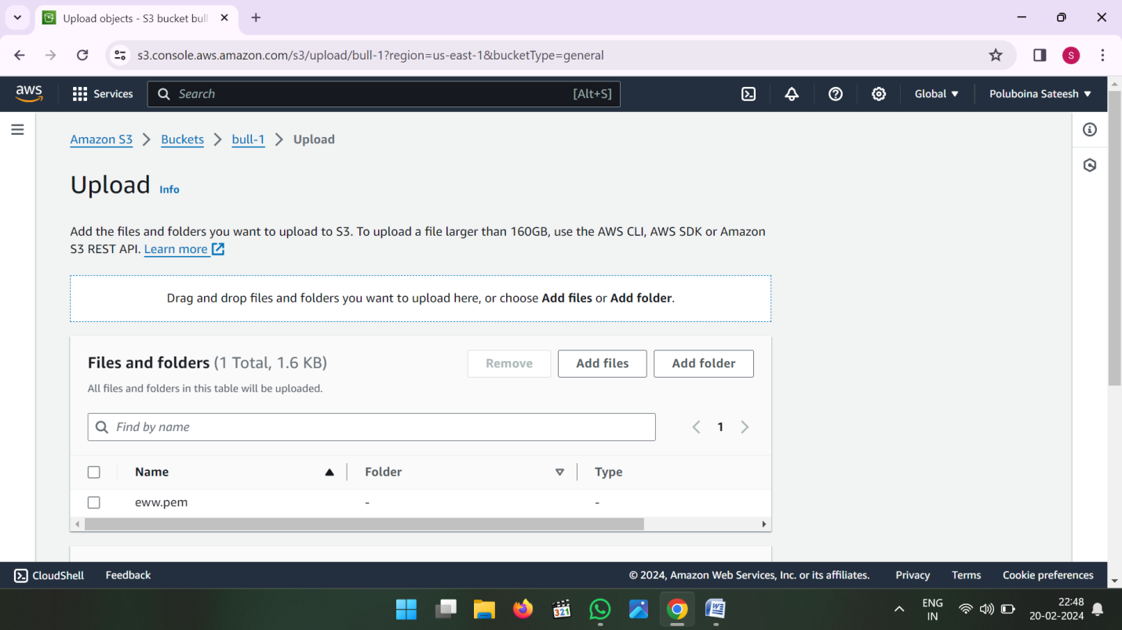

* Click on Upload

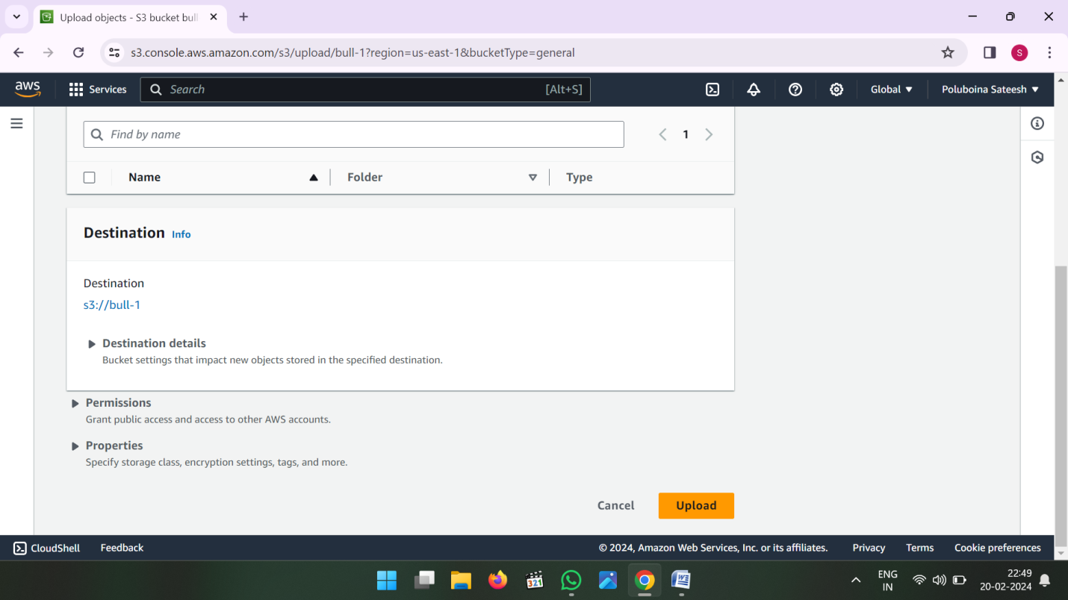

* Uploading Files and Folders

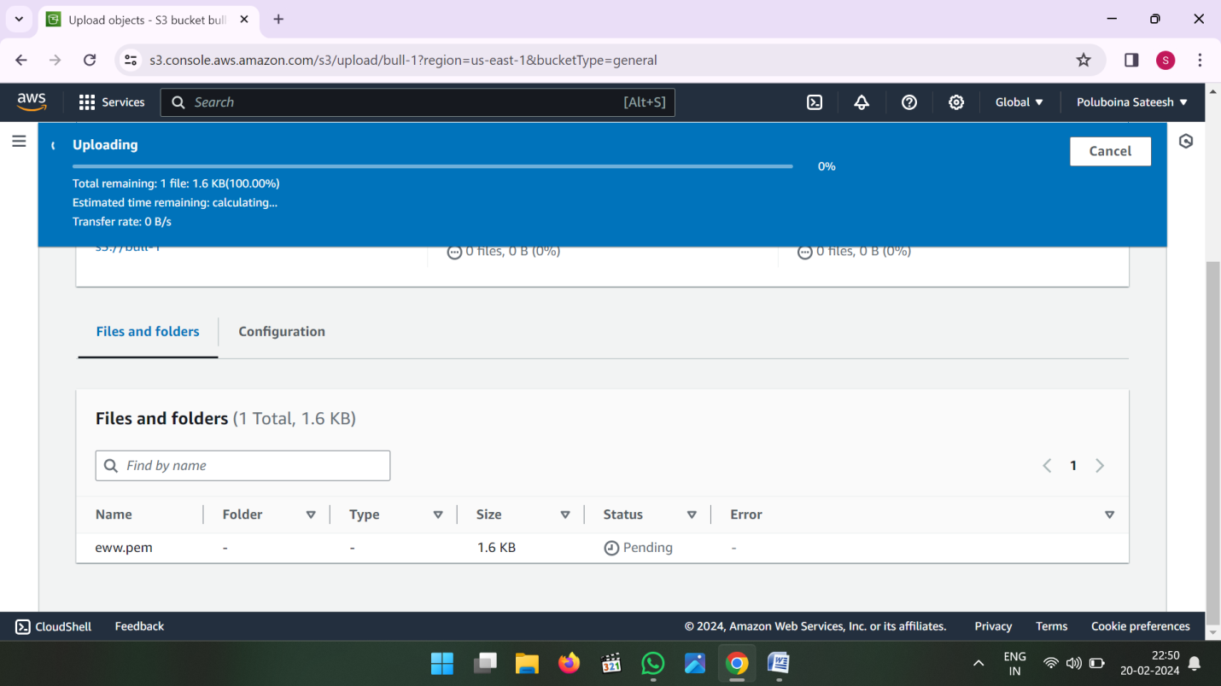

* Now go to Management in first bucket (or) Source Bucket

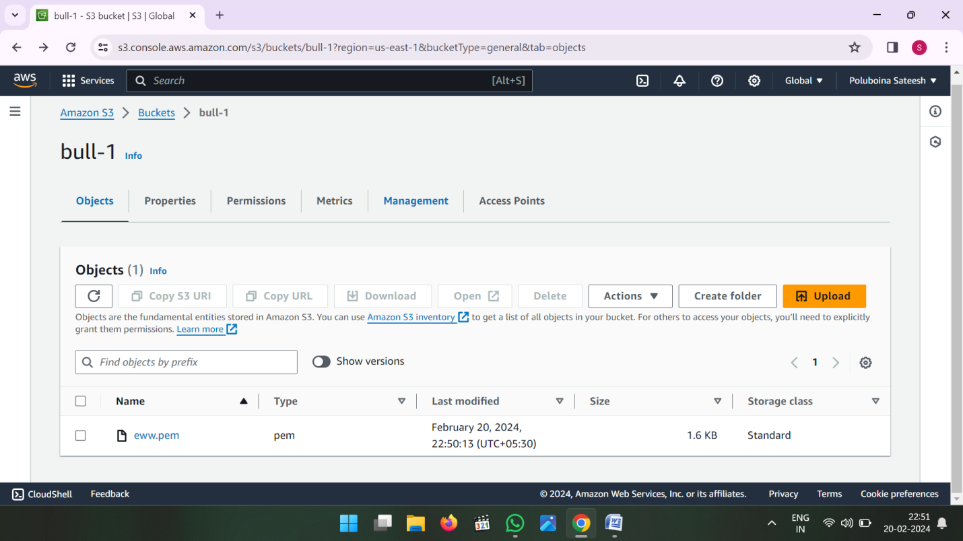

* In Management Console click on create Replication Rule

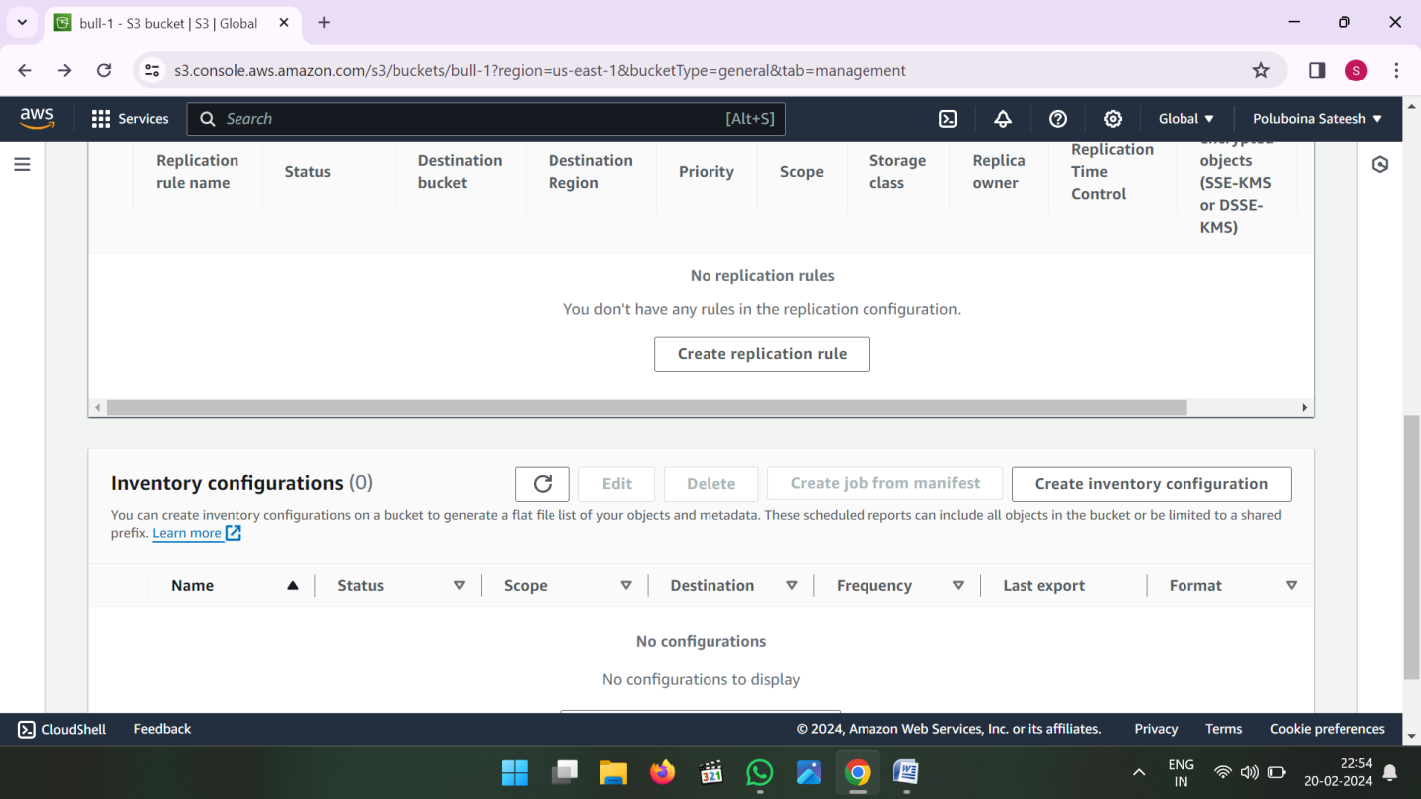

* Enter Replication rule name

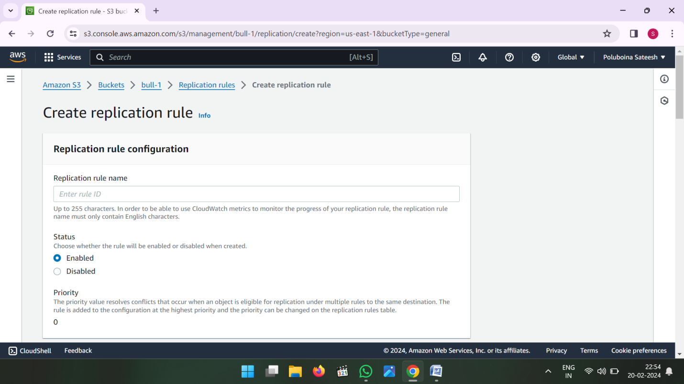

* Click on Apply to all objects in he bucket

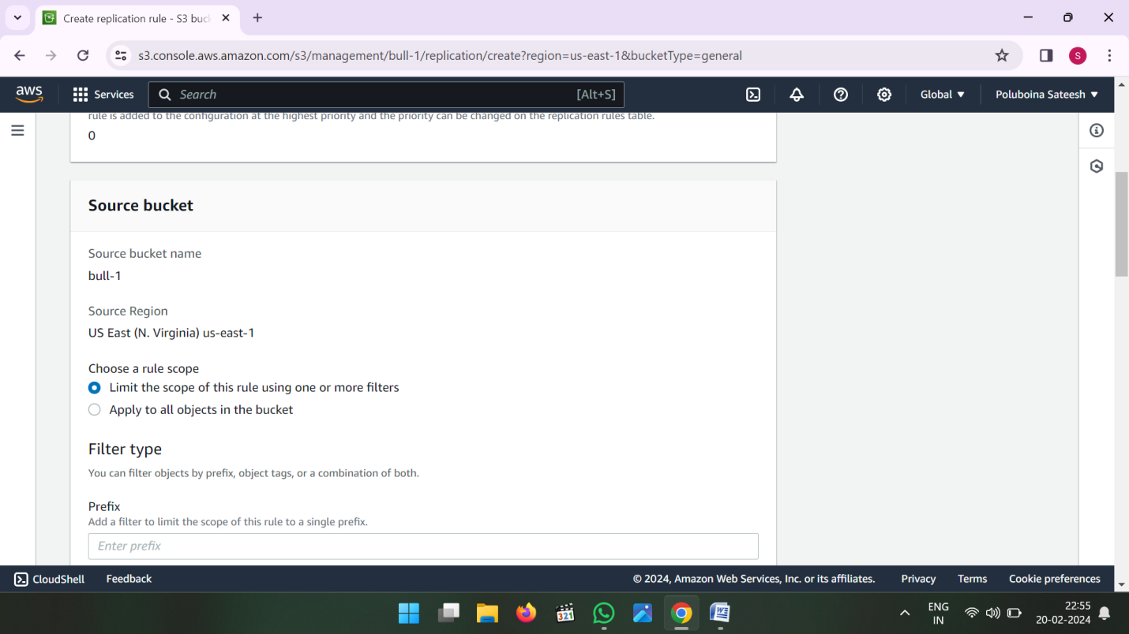

* Now Choose Destination where ever you want to see the data

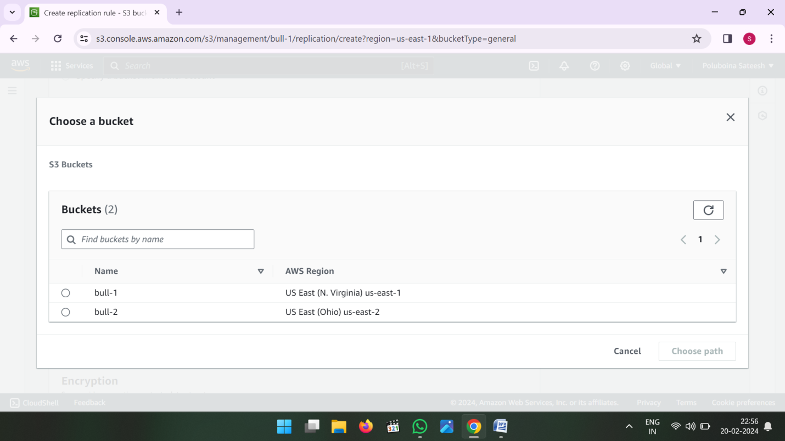

* Choose a bucket in this account

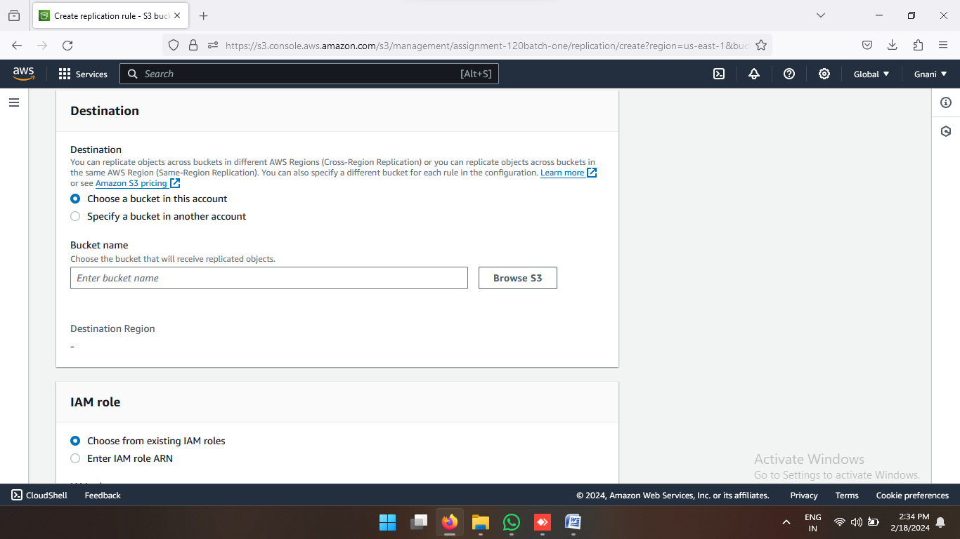

* Select another region Bucket (or) Where ever you want to see the data that bucket select and click on choose path

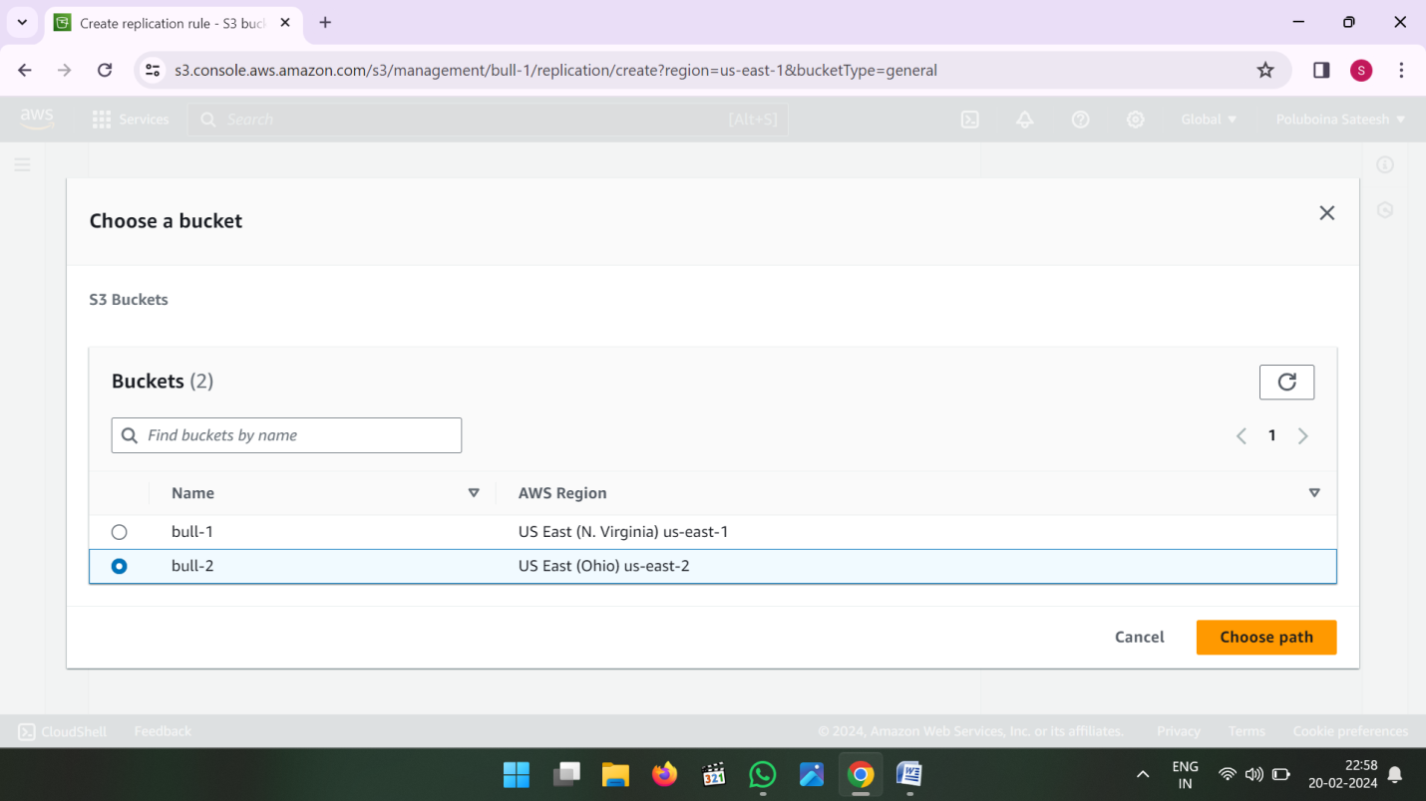

* Now choose from existing IAM roles

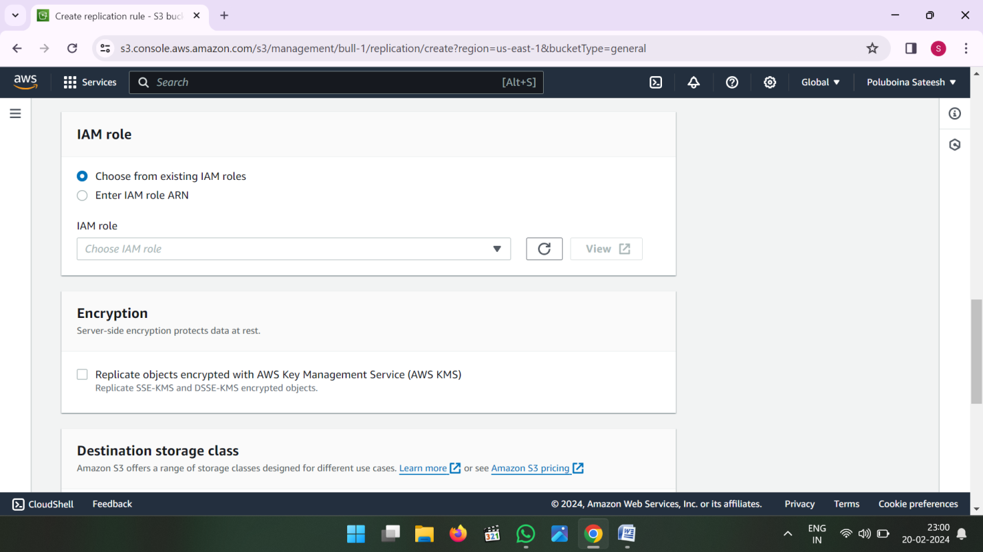

* Select Drop down Create a new role

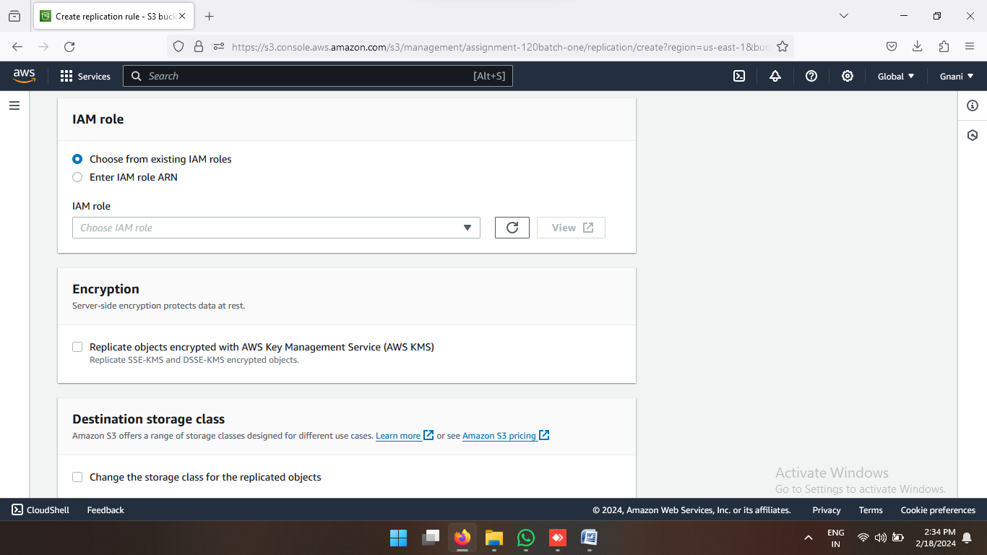

* Then Save the Replication Rule

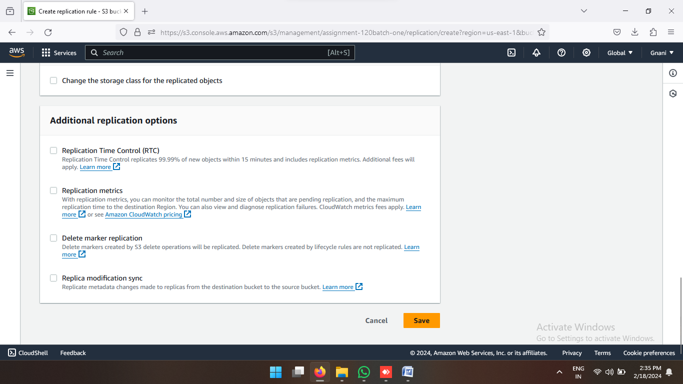

* Now if you want see the existing data then click on Yes
* If you don’t want to see the existing data then click on No then submit

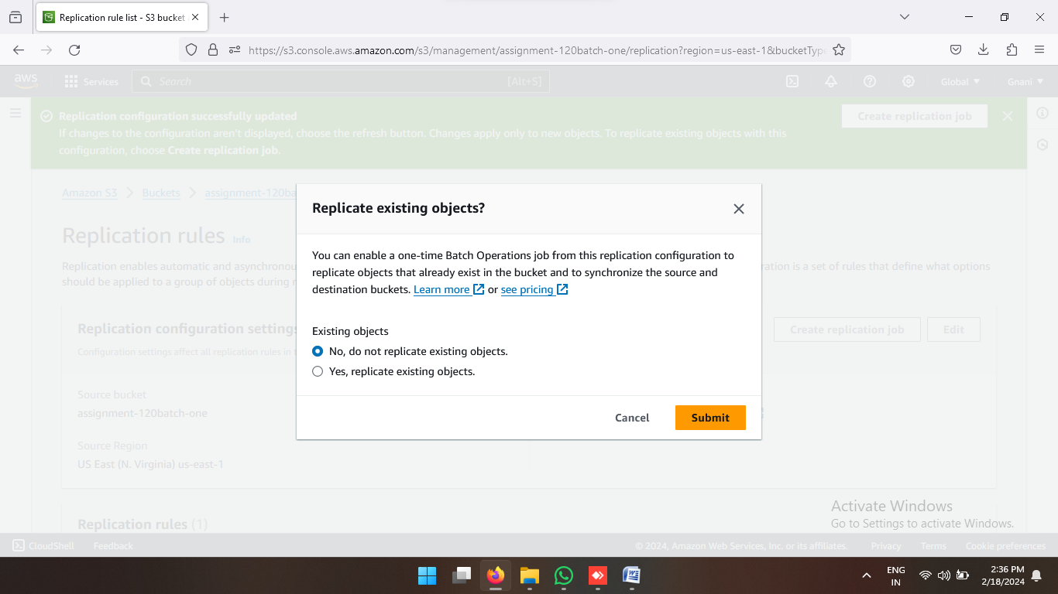

* If You Click yes then choose the destination path again and click on save button

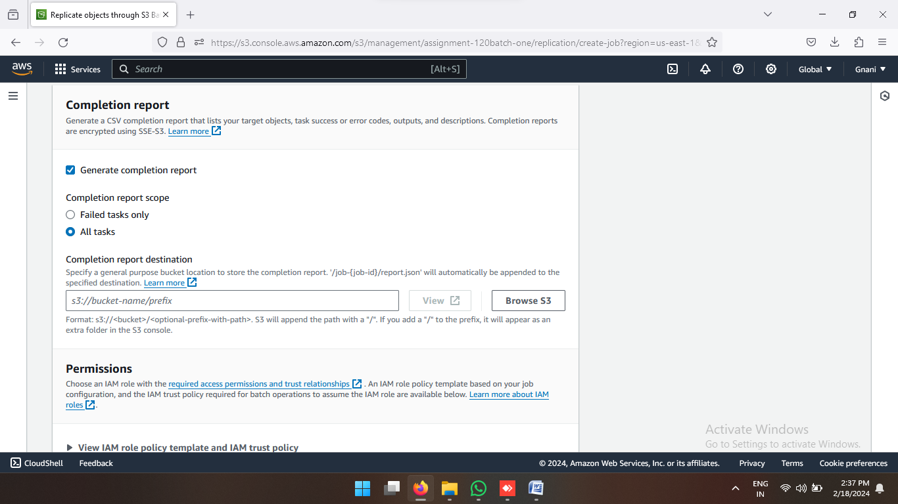

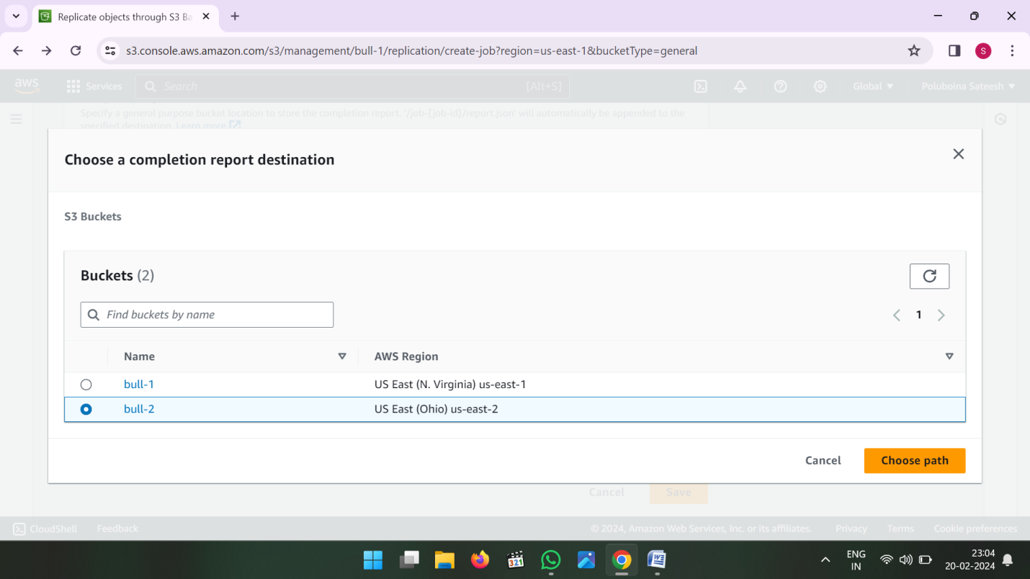

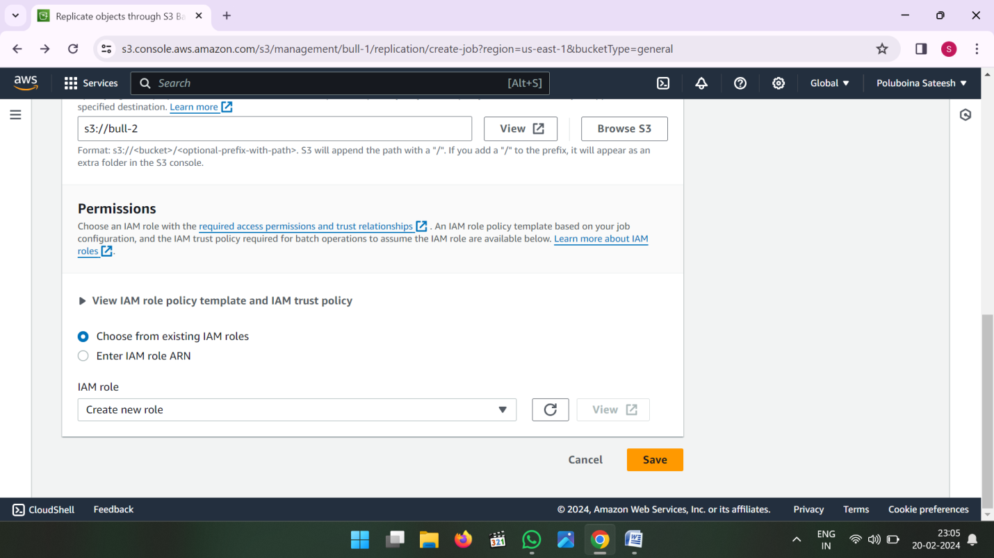

* After Save Button Click then one batch Operation Created that status is showing Preparing.
* Status is changed active then we can see the data into the destination bucket.

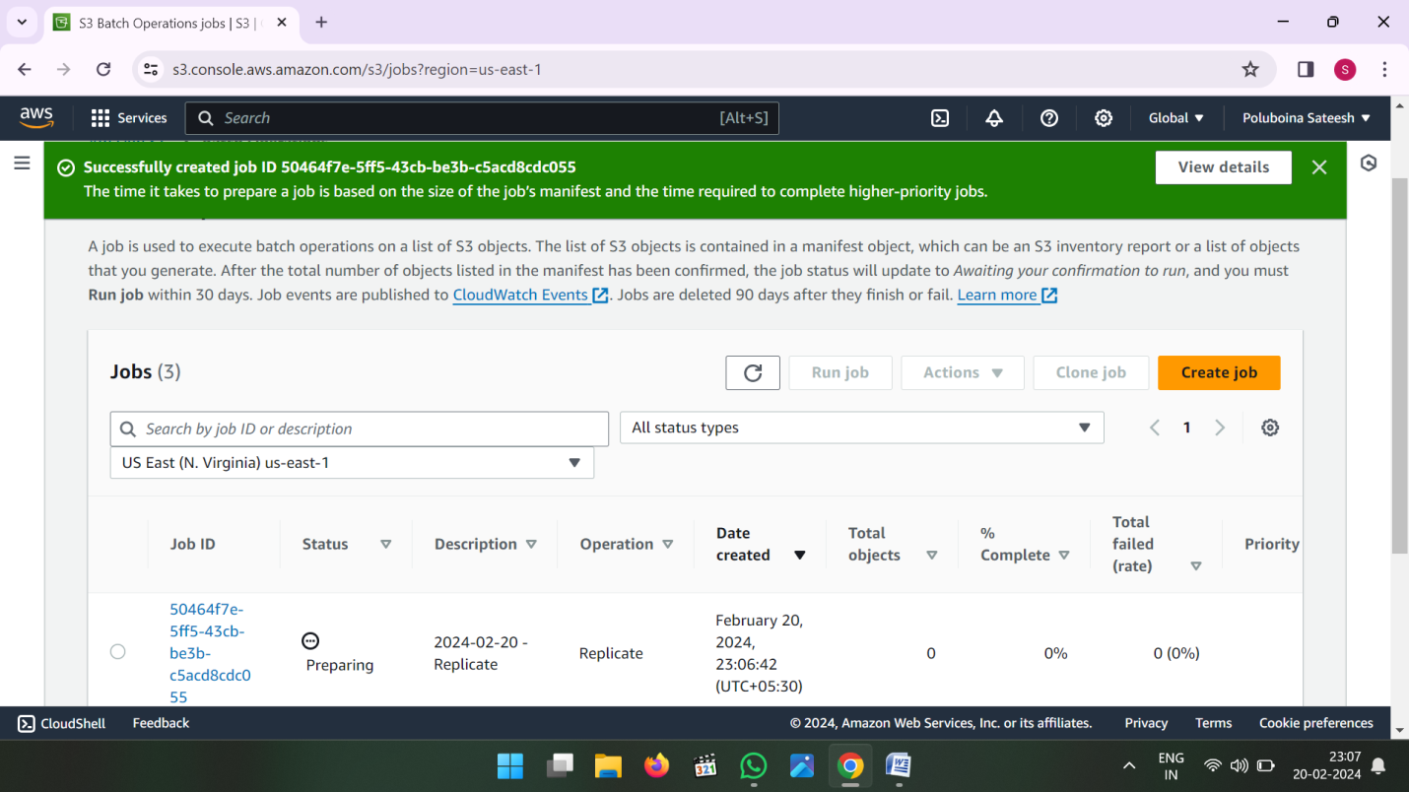

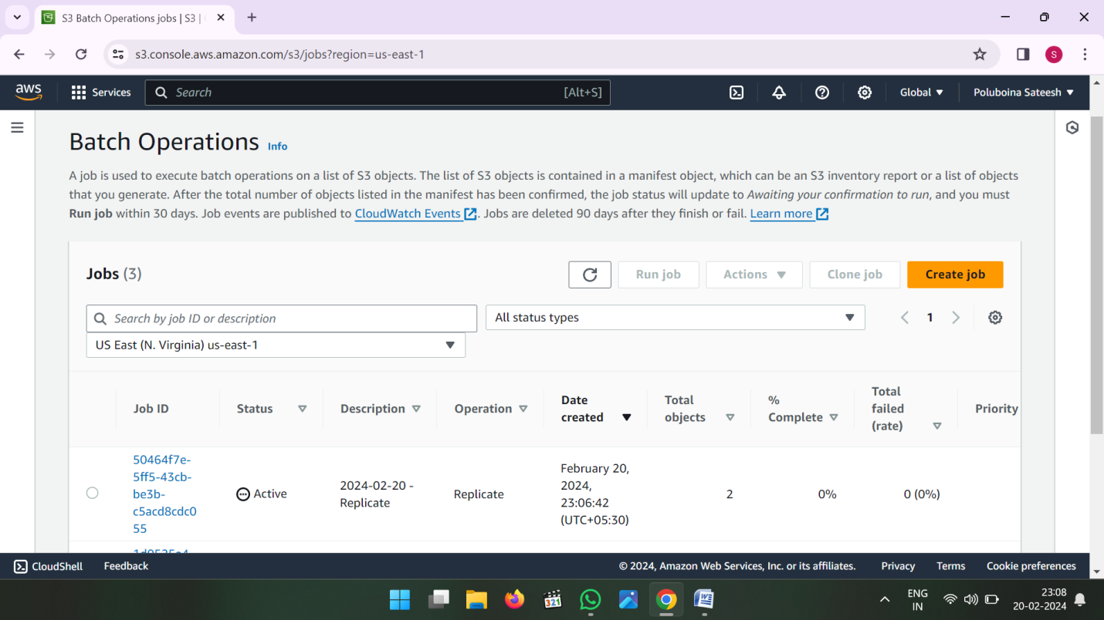

* Whenever Batch Operation Active go to Destination Bucket and see the data.

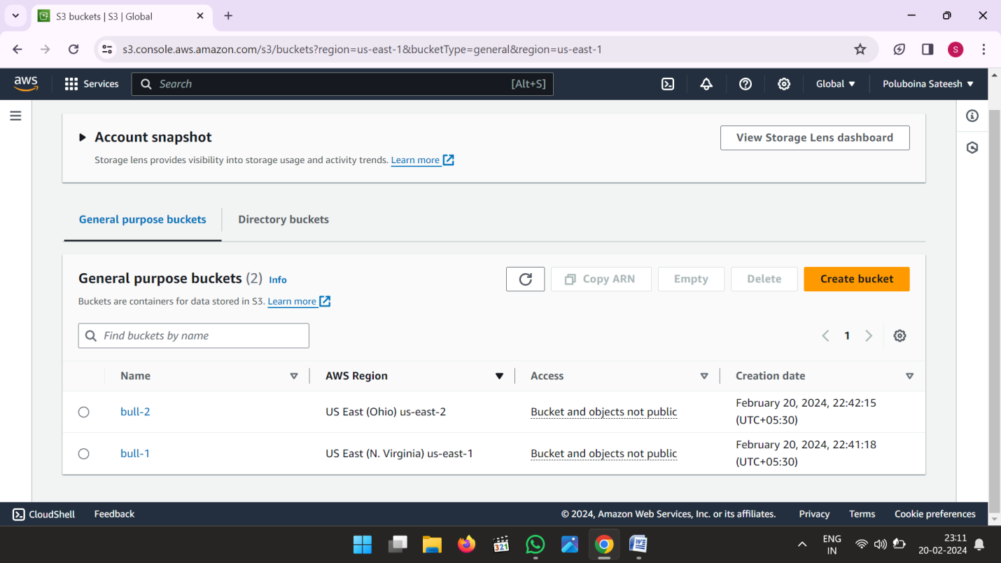

* Now See the data in Destination Bucket.

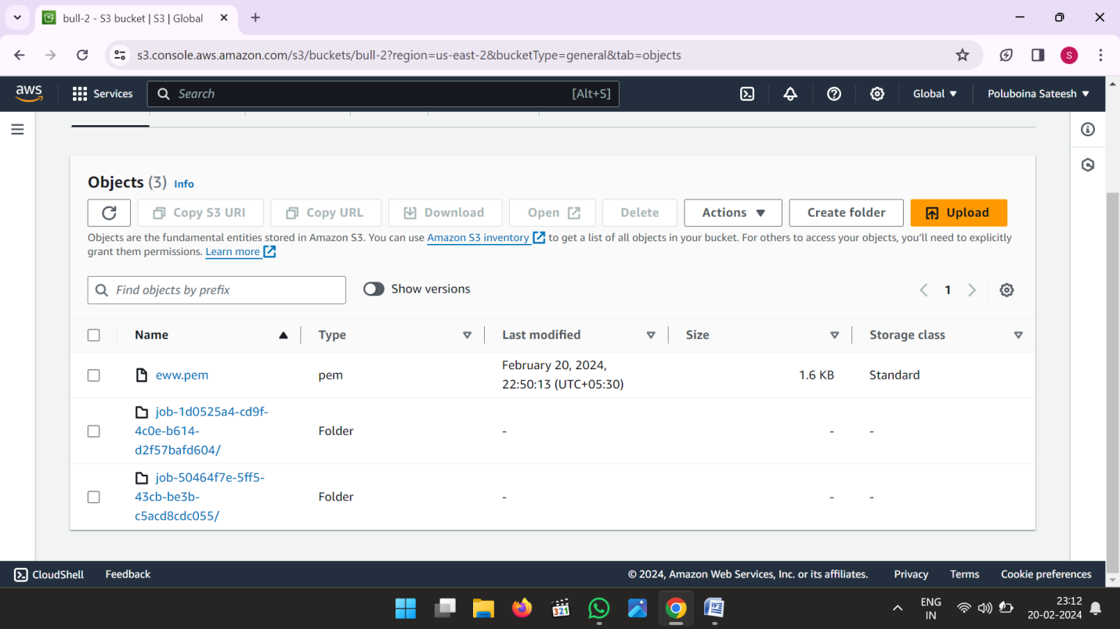

****************************** END *******************************

**3) Create ebs and attach volume to an instance and unmount the volume and attach to another instance?**

* Go to AWS Console Home and search EC2 and Click on EC2

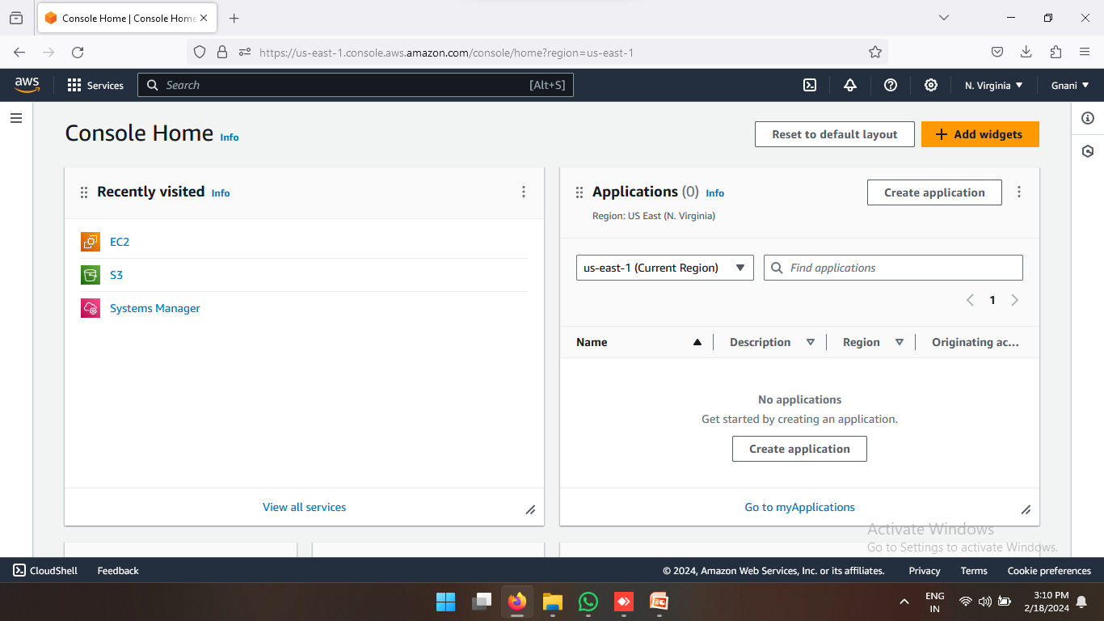

* Now we are in EC2 Dashboard
* Click on Instances

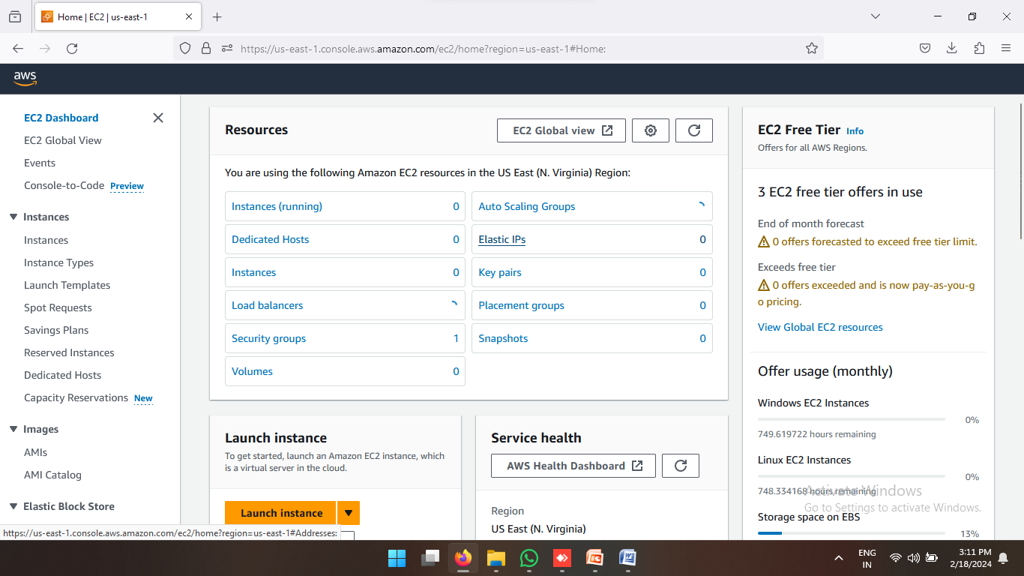

* Now Create One Server in any region
* Click on Launch Instances

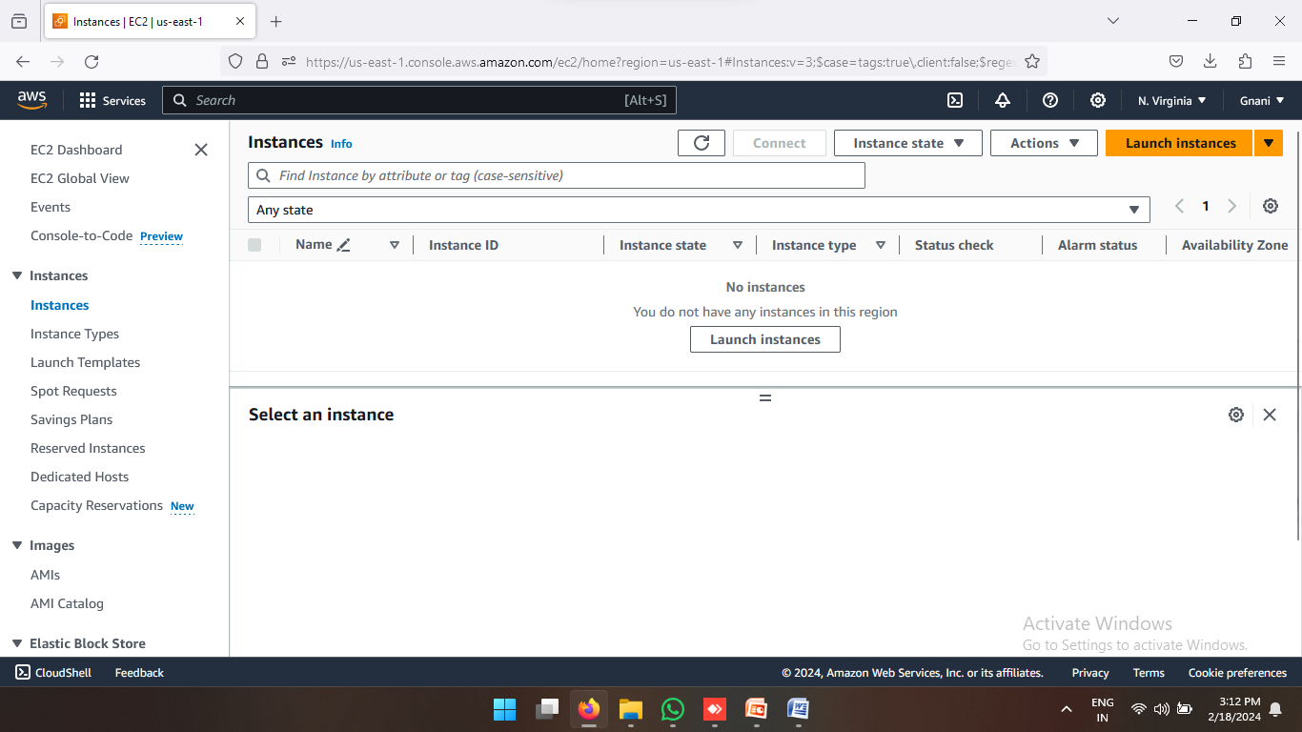

* Enter Name and select operating system

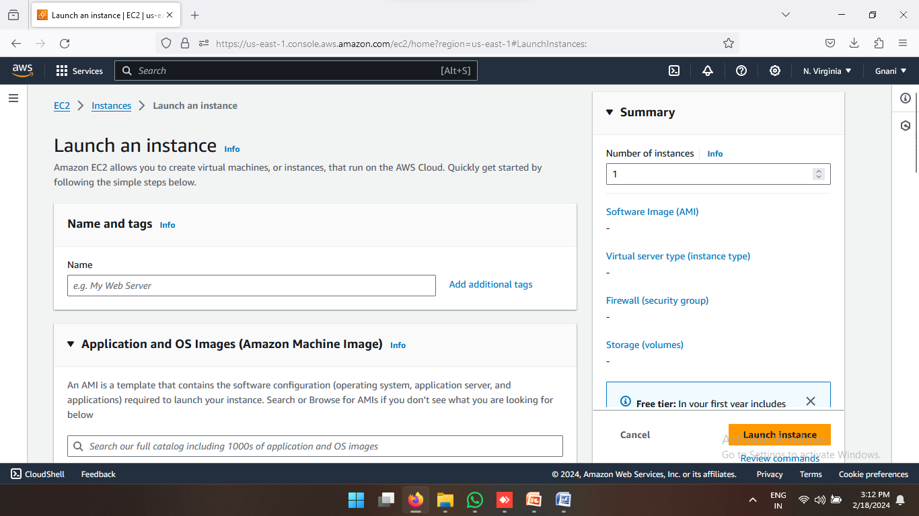

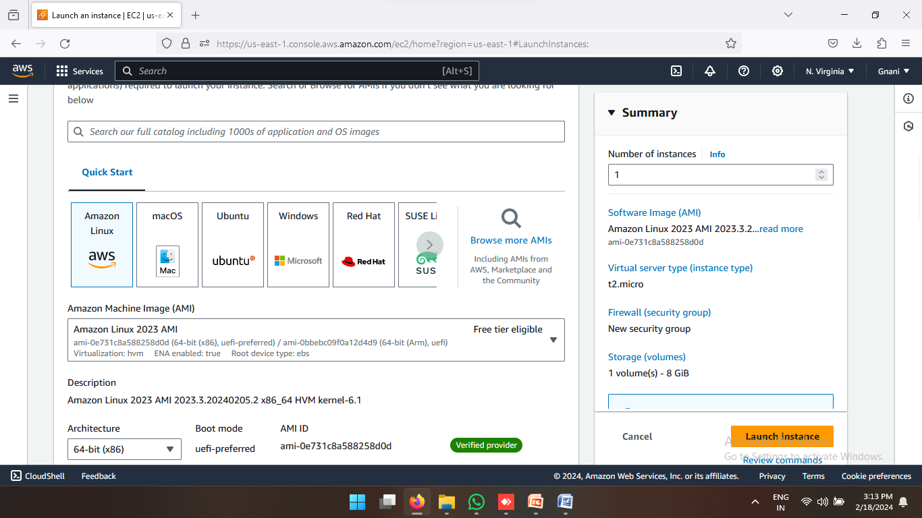

* Now Click a Create new key pair

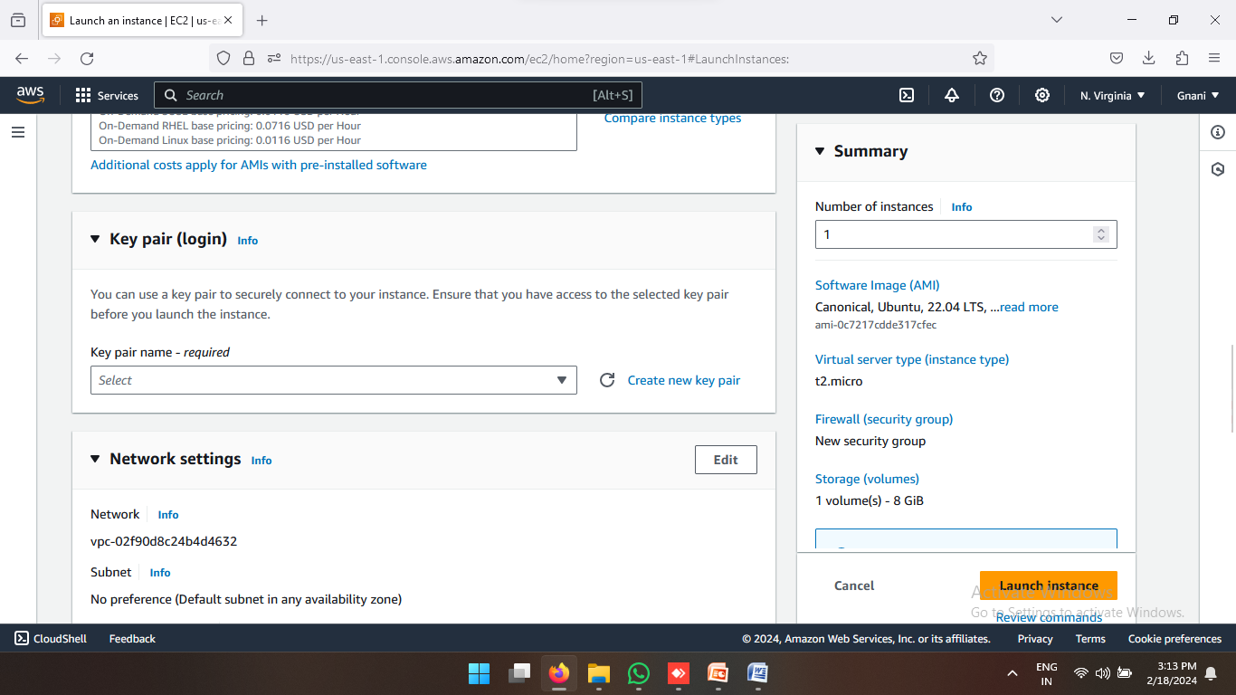

* Enter a key name and click on create key pair

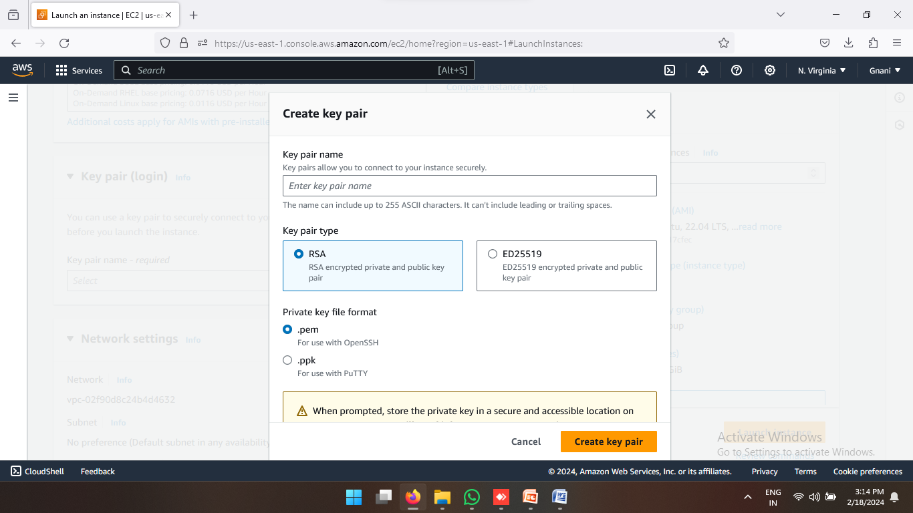

* Now Click on launch instance

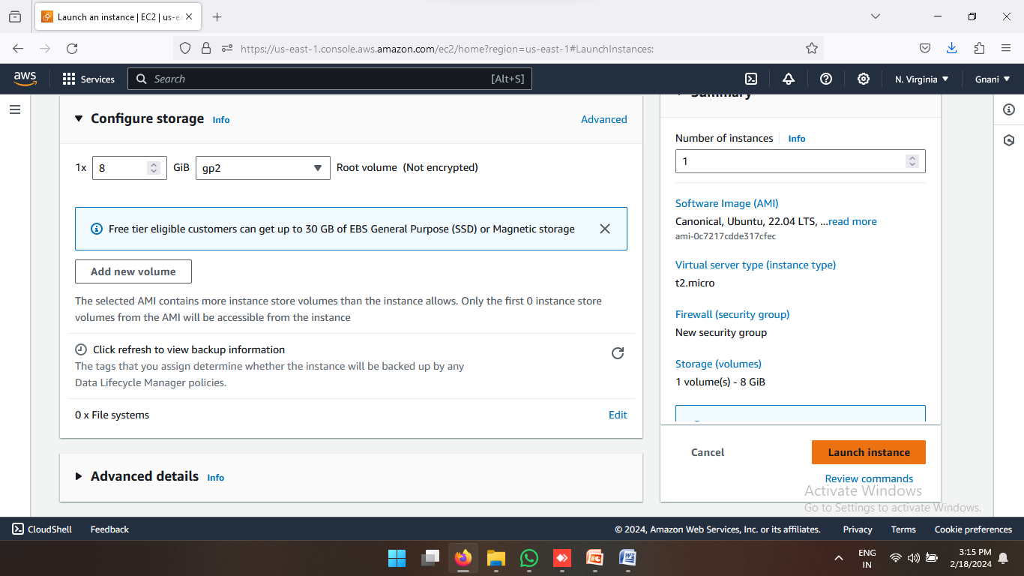

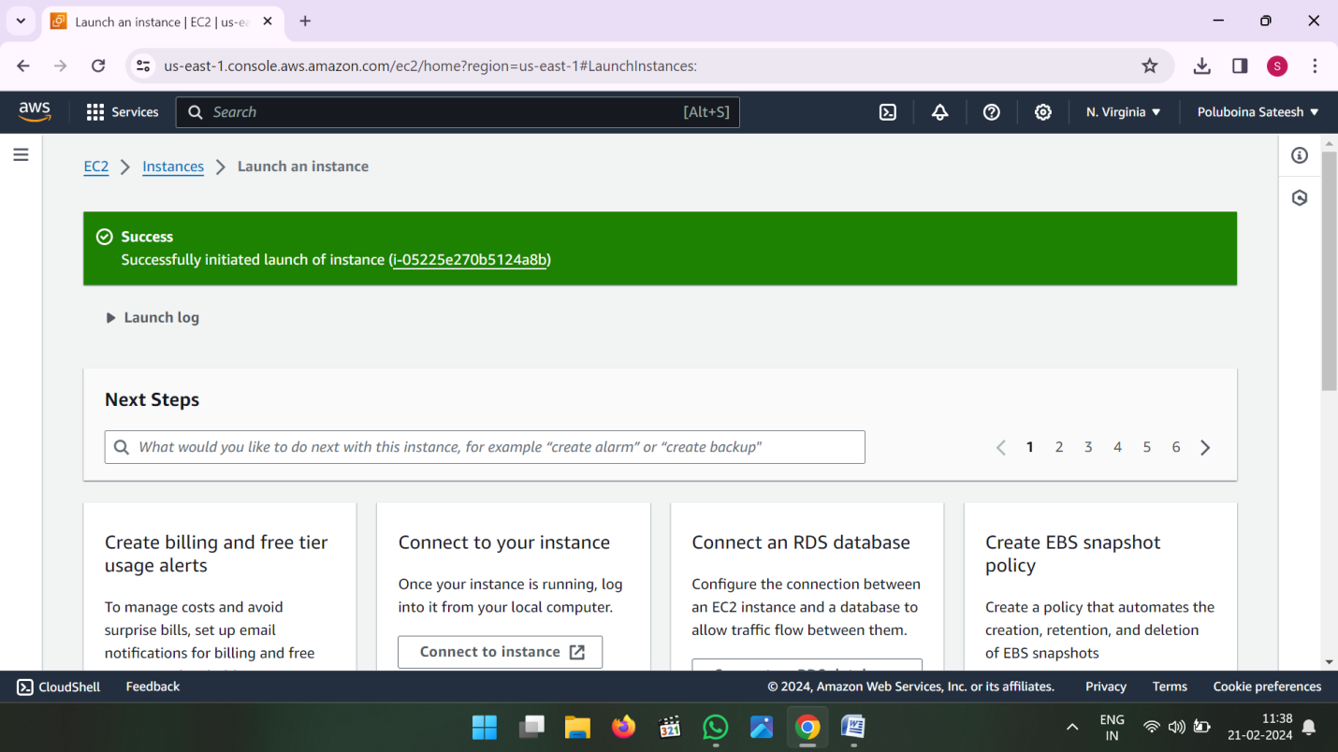

* One server (or) Instance Created and Click on instance id then connect

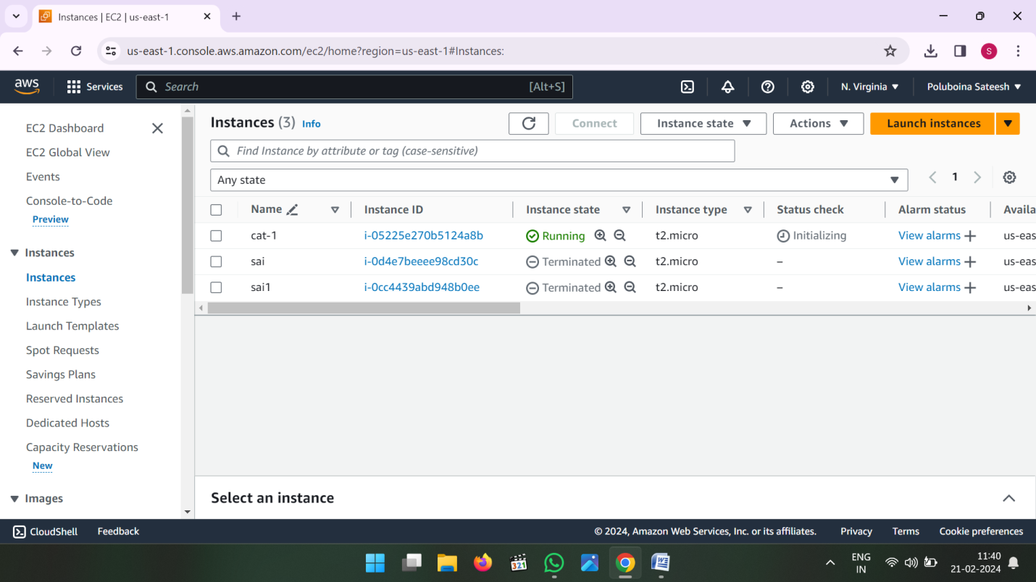

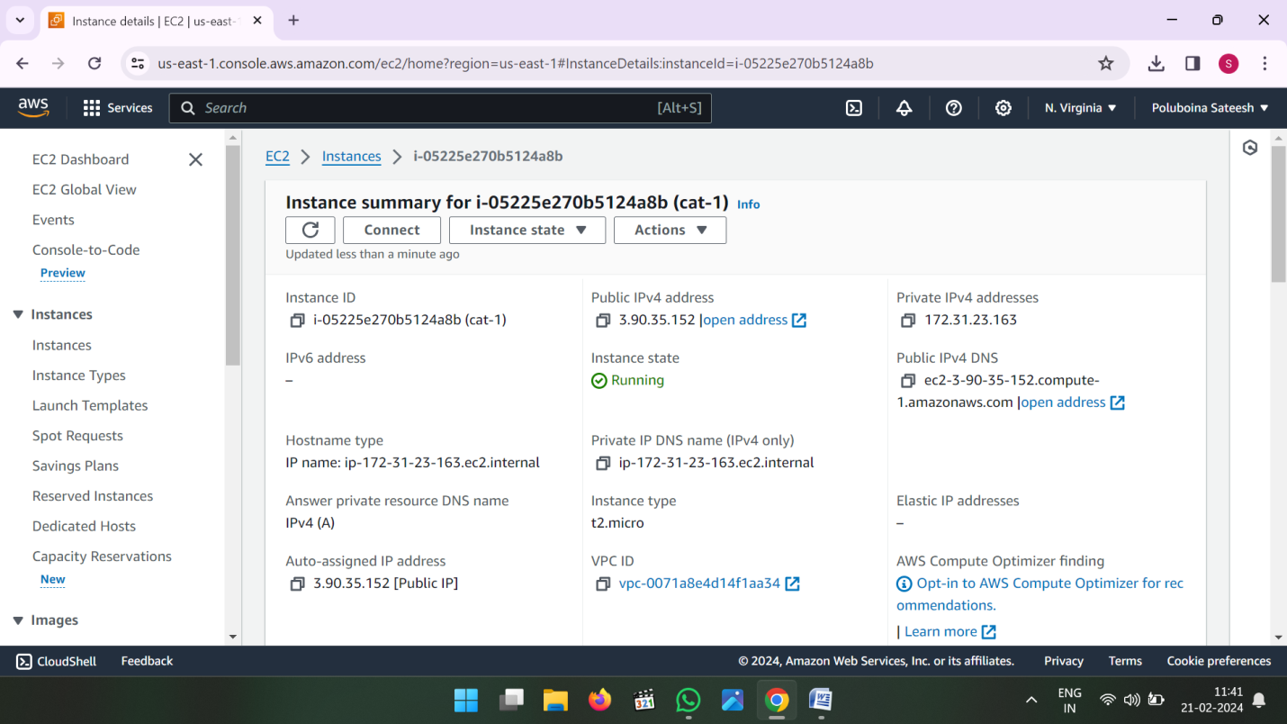

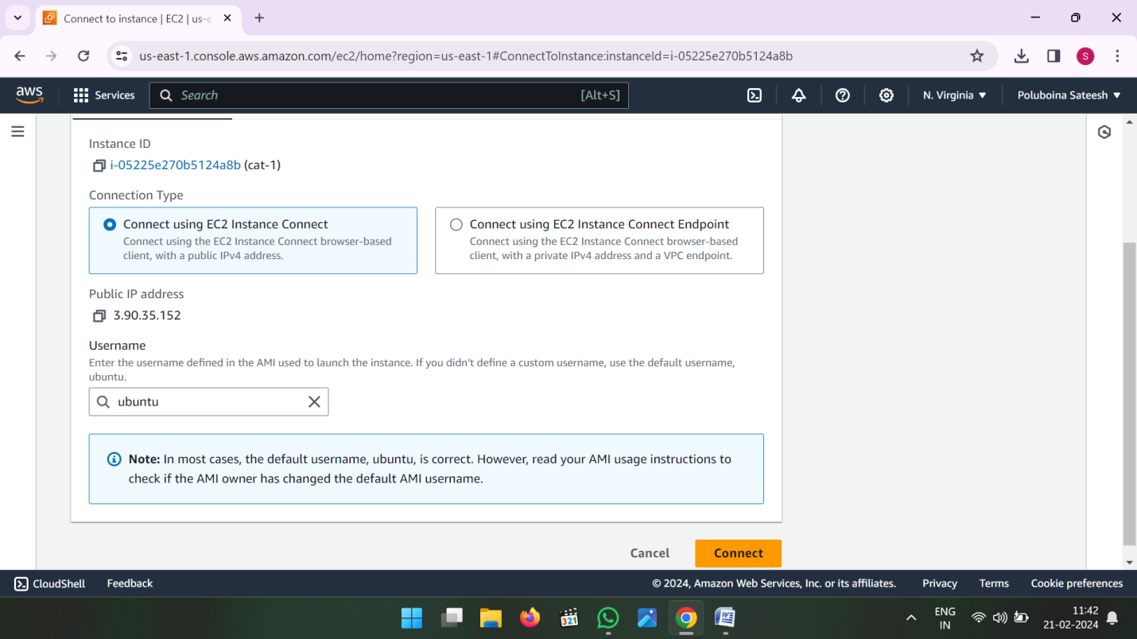

* Now Connected server

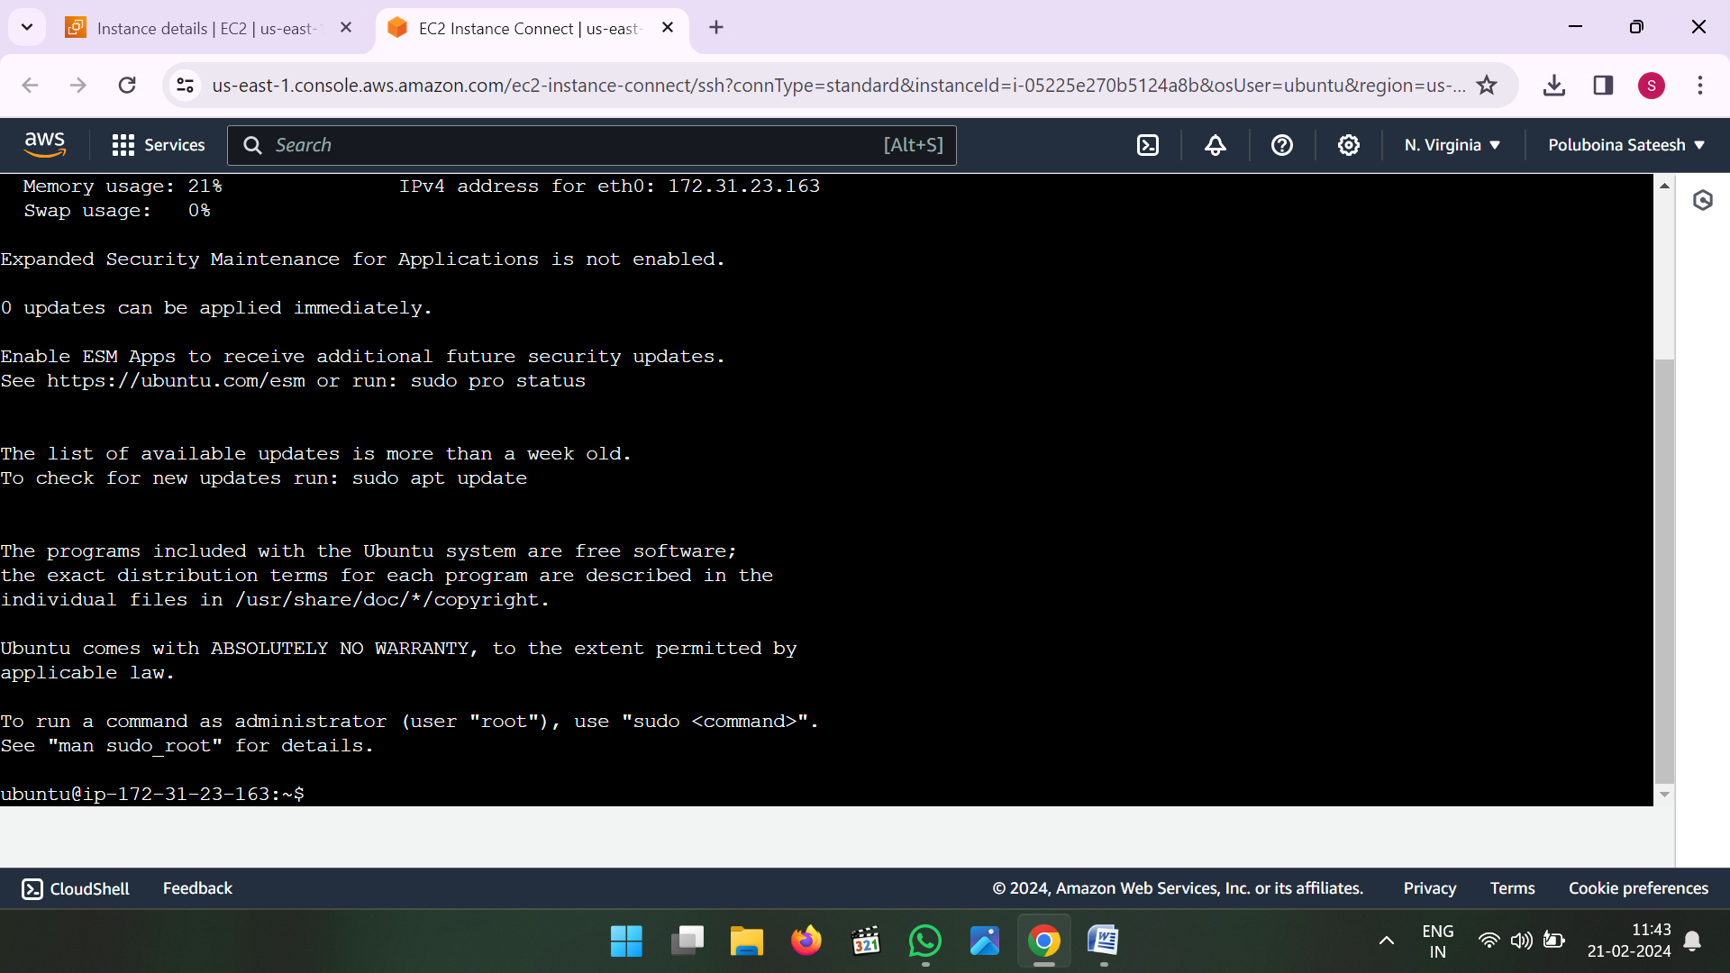

* **df –h** this command check user size

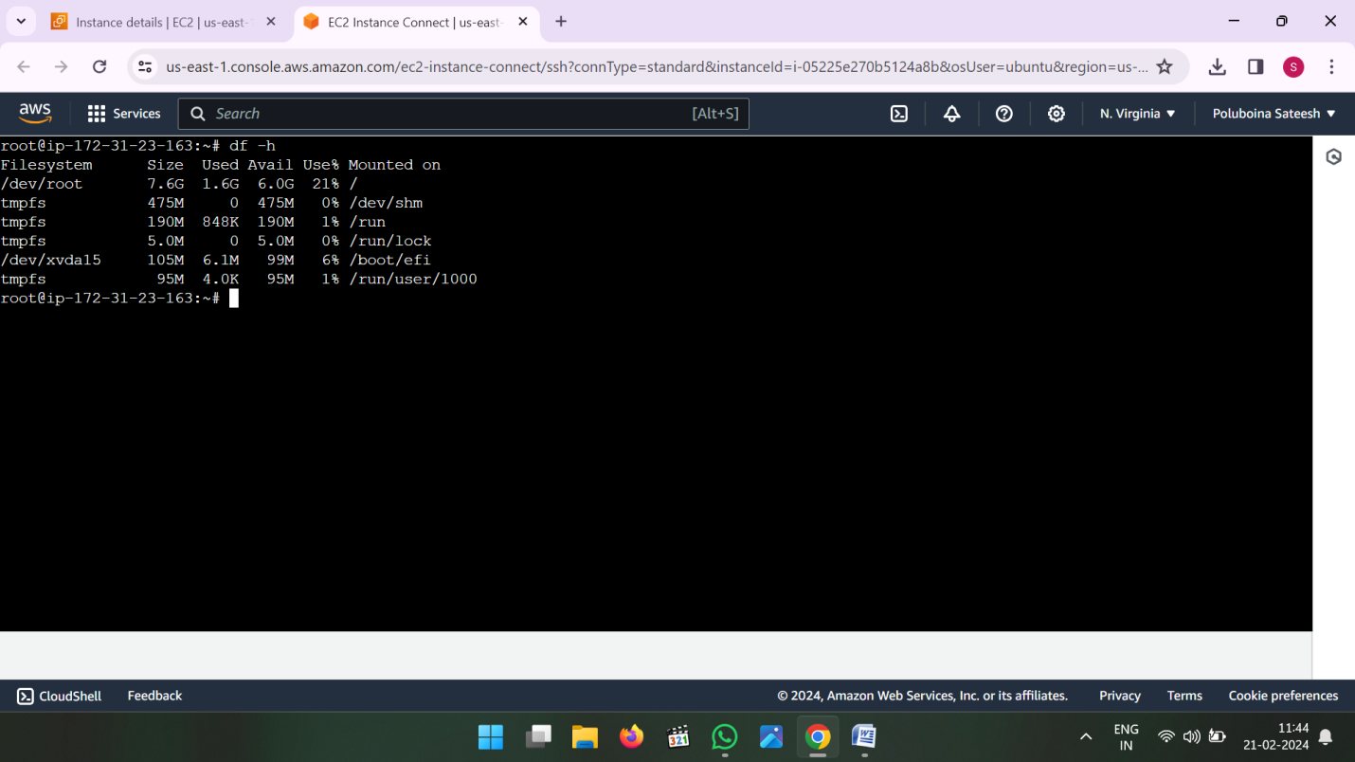

* Now go to ebs then volumes

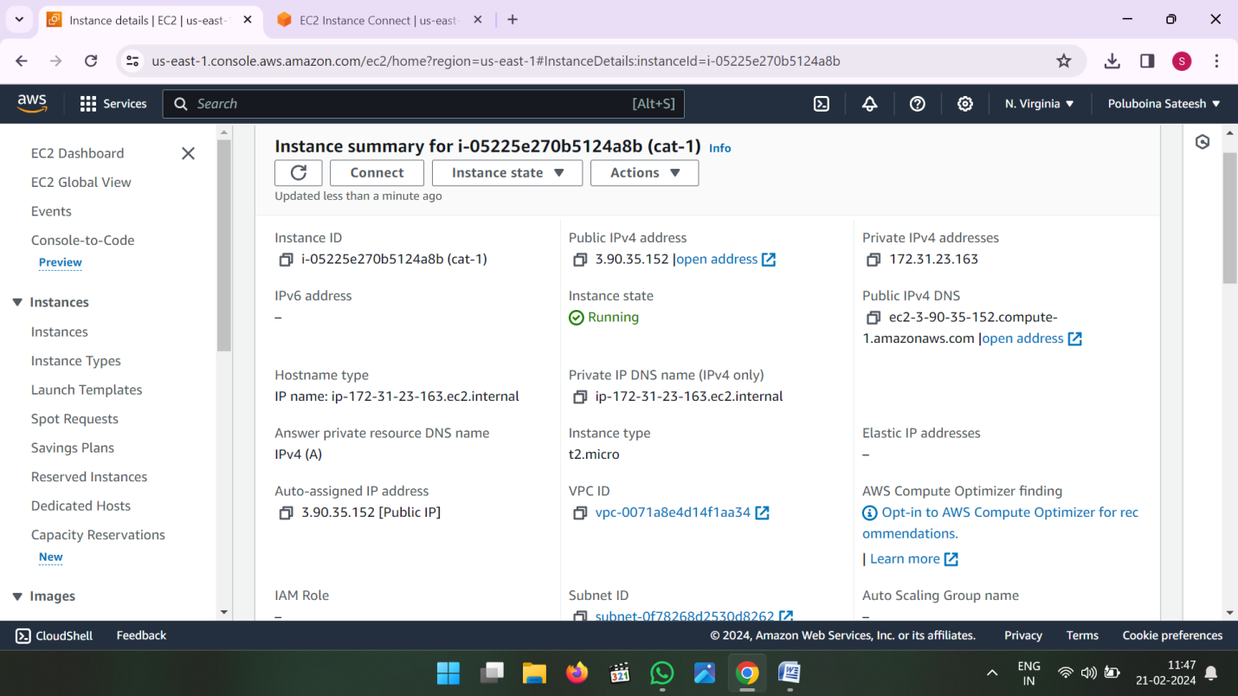

* Click on Create Volume

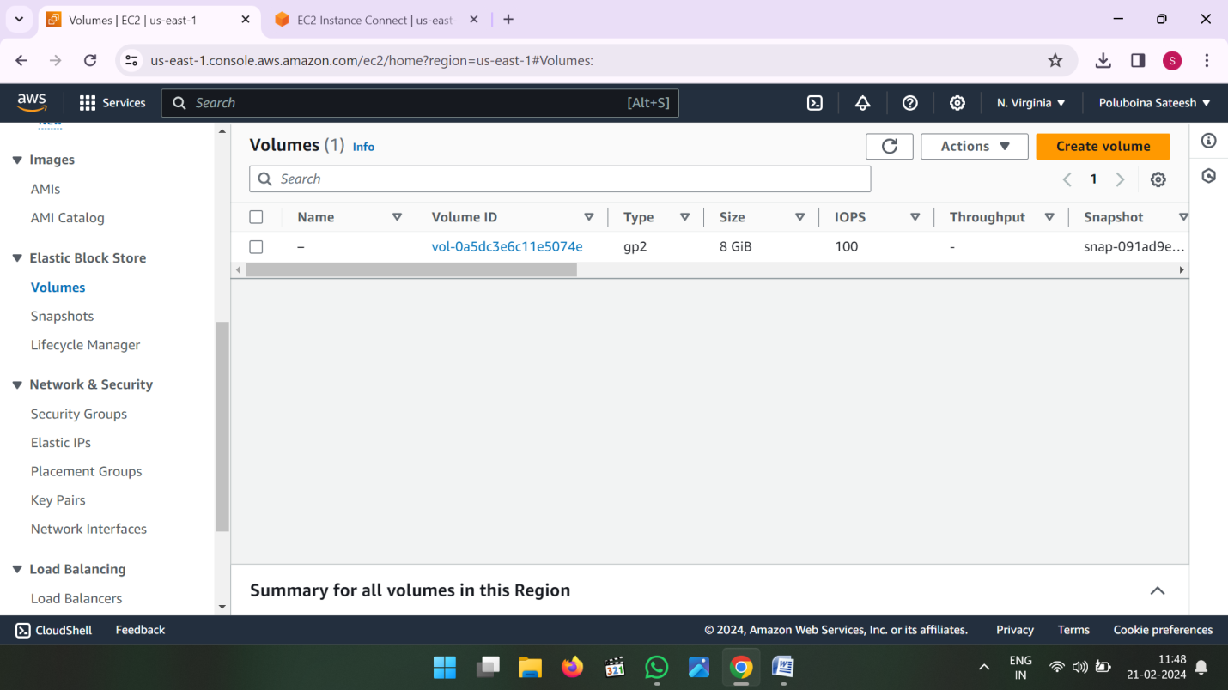

* Enter the size what ever you want then select same availability zone of EC2 then create volume

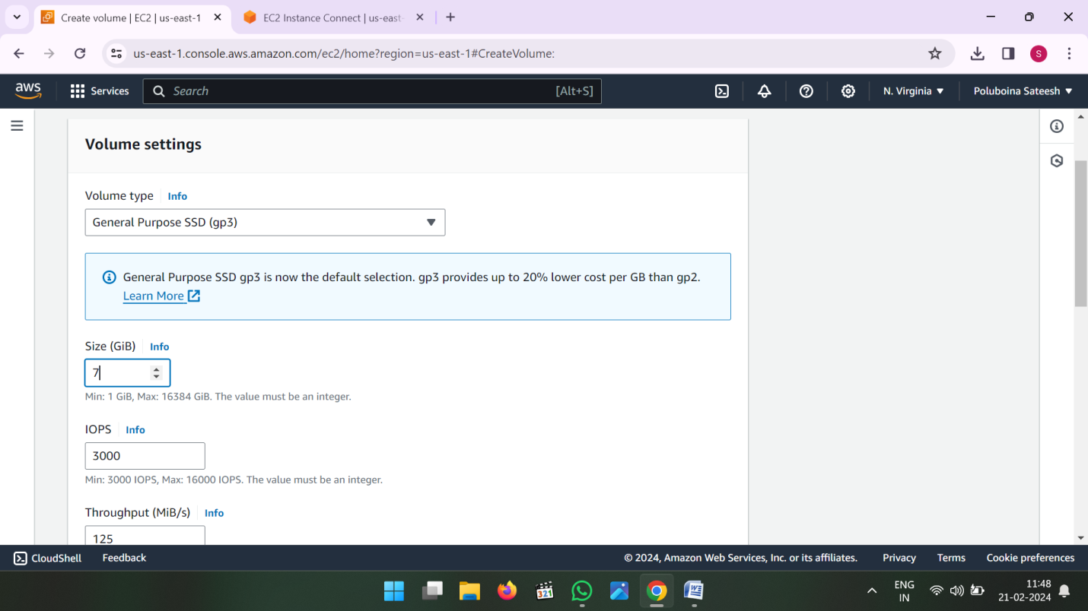

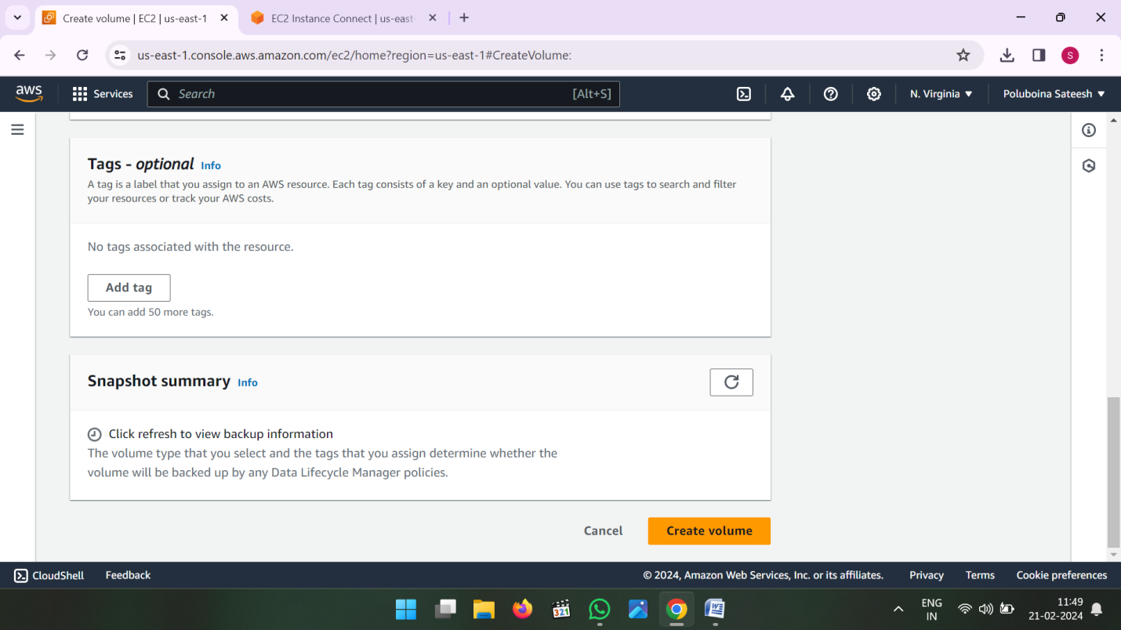

* After Create a volume see the status of created volume it is available state is showing.
* Select that volume and attach volume to our first instance.
* After Attach volume that should be disable. And detach is enable.

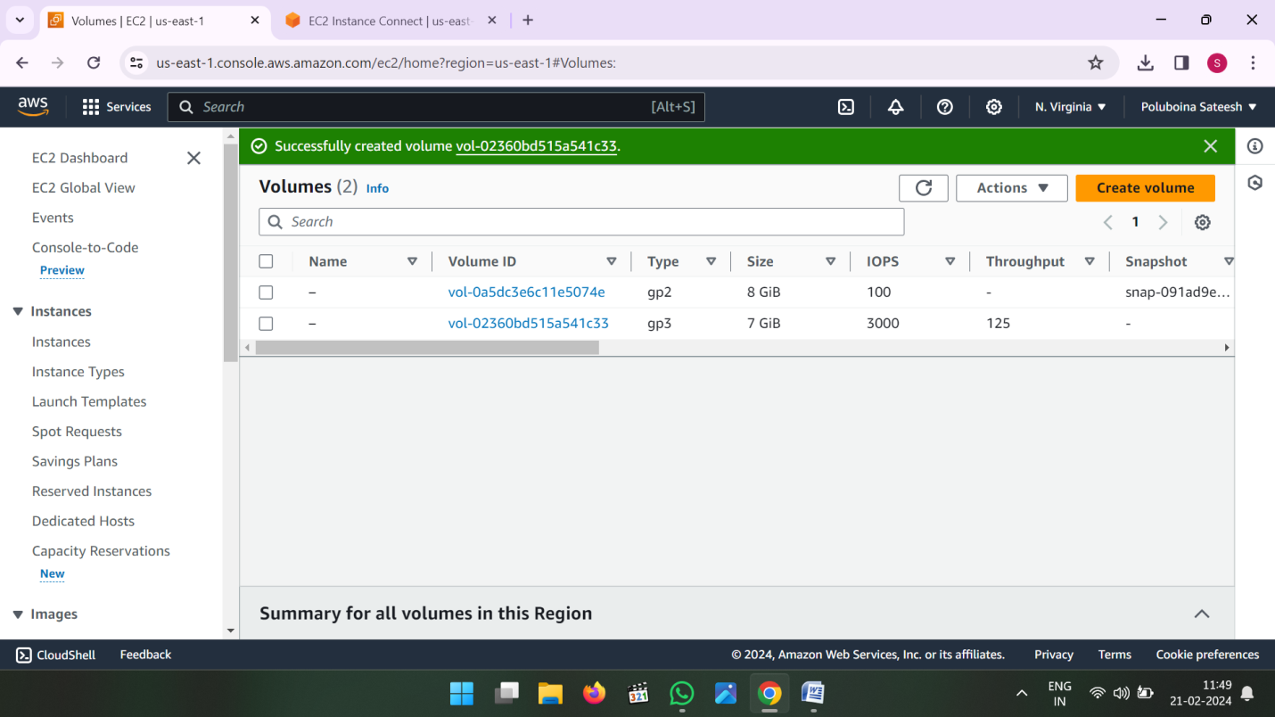

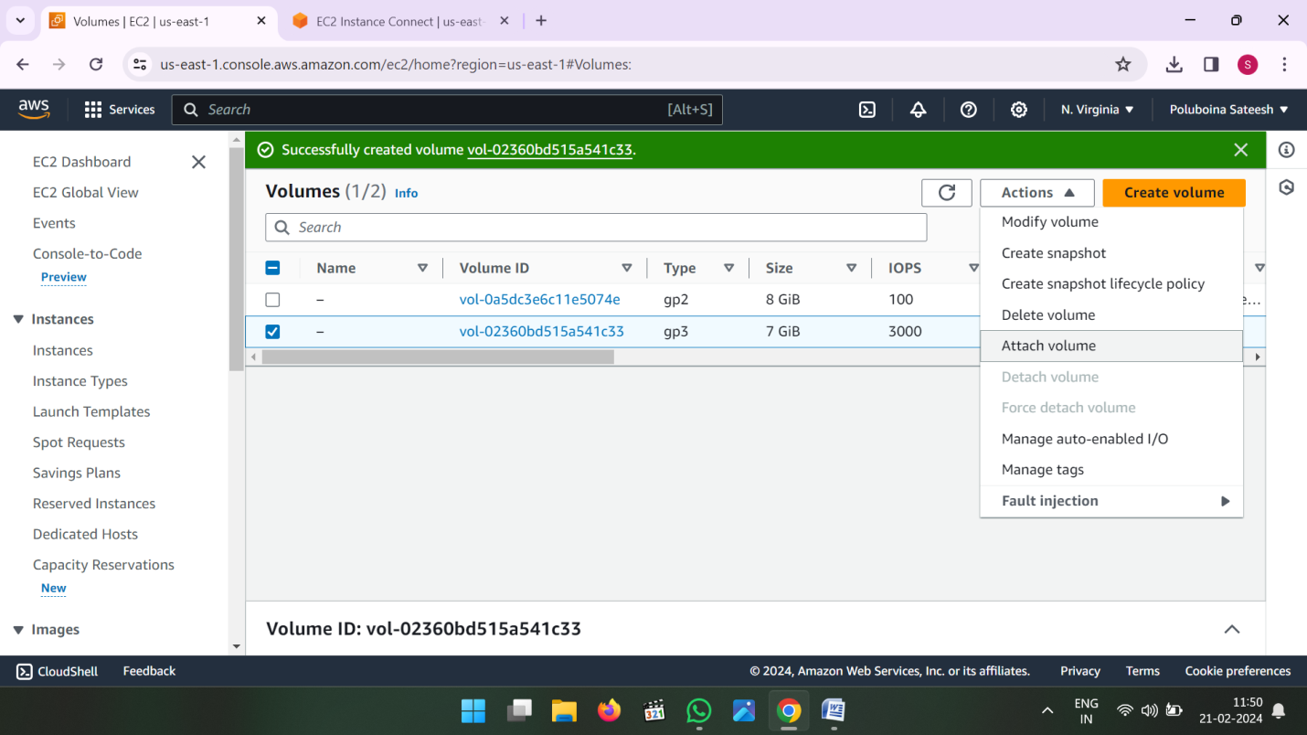

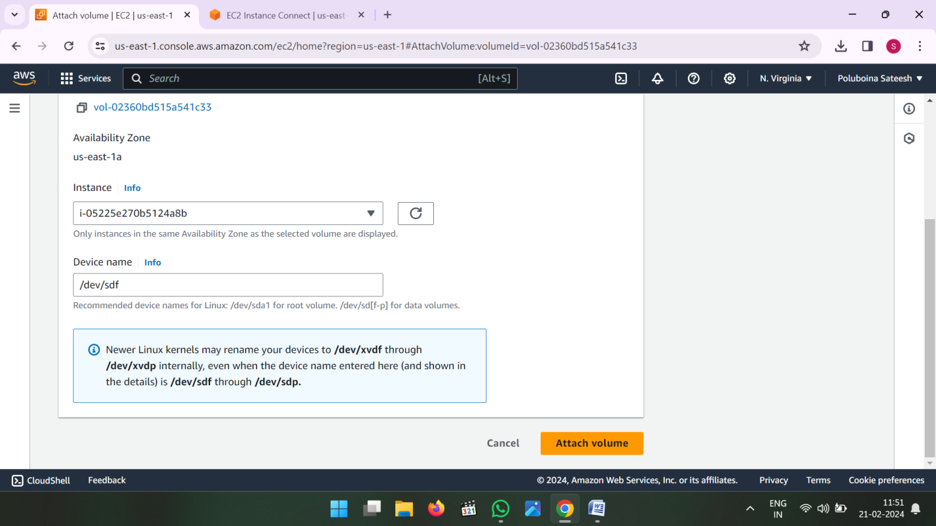

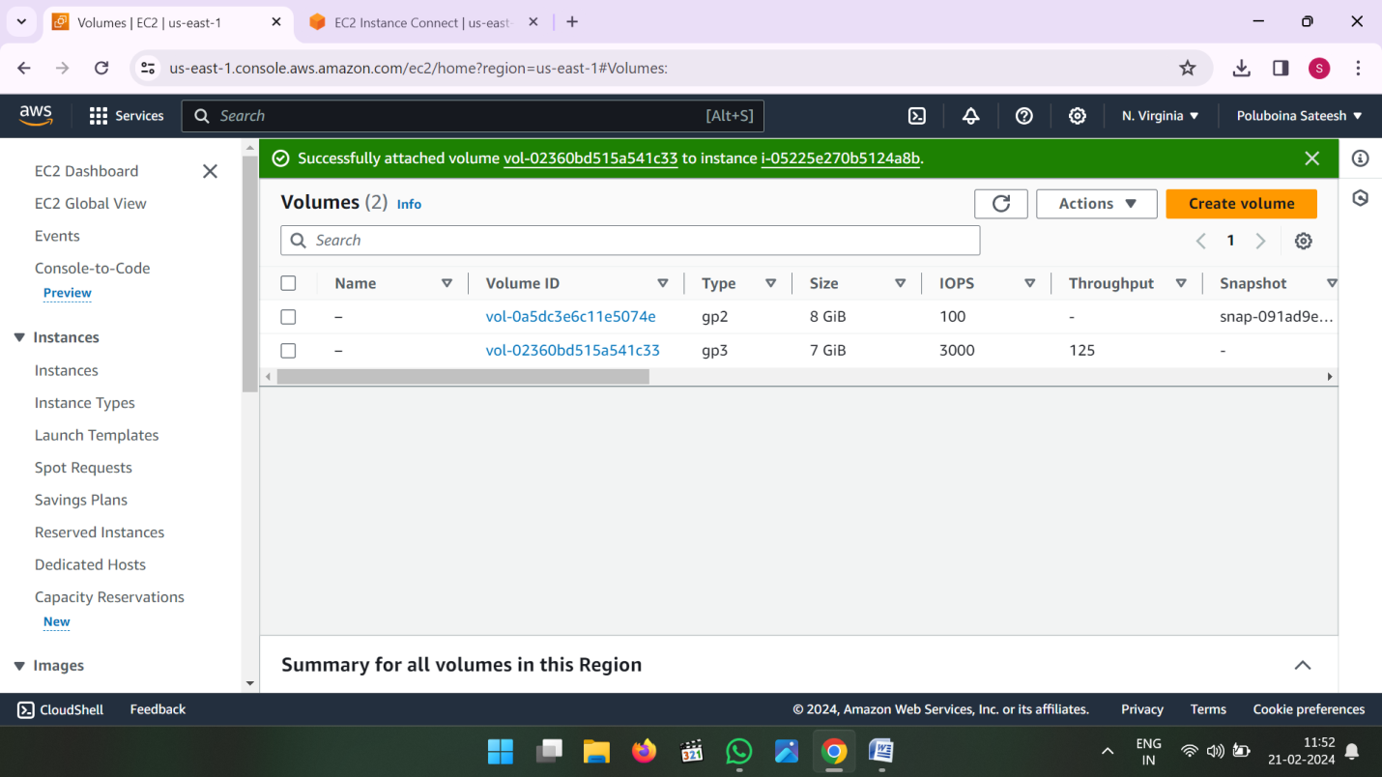

* Now Go to EC2 Connected server
* Enter Command for volume is attached or not
* Command is “**lsblk”**

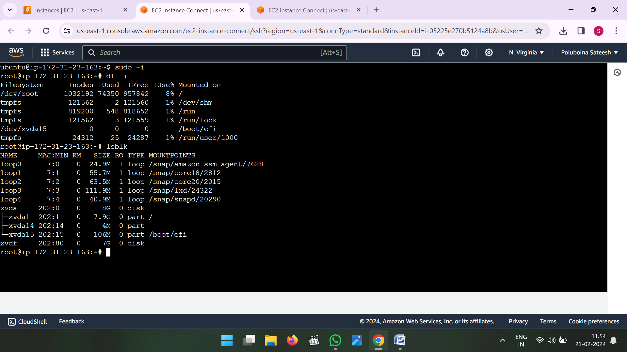

* First to check file system is there or not then create new File system in volume
* Command is **mkfs –t xfs /dev/xvdf**
* To Check file system created or not command is **file –s /dev/xvdf**
* Create directories and mount the volume to directories

Command is

**mkdir –p vcube/batch**

**mount /dev/xvdf vcube/batch**

**cd vcube/batch**

**mkdir 124 145**

**vi file1**

**ls – see the list files and directories**

**cd**

**umount /dev/xvdf vcube/batch**

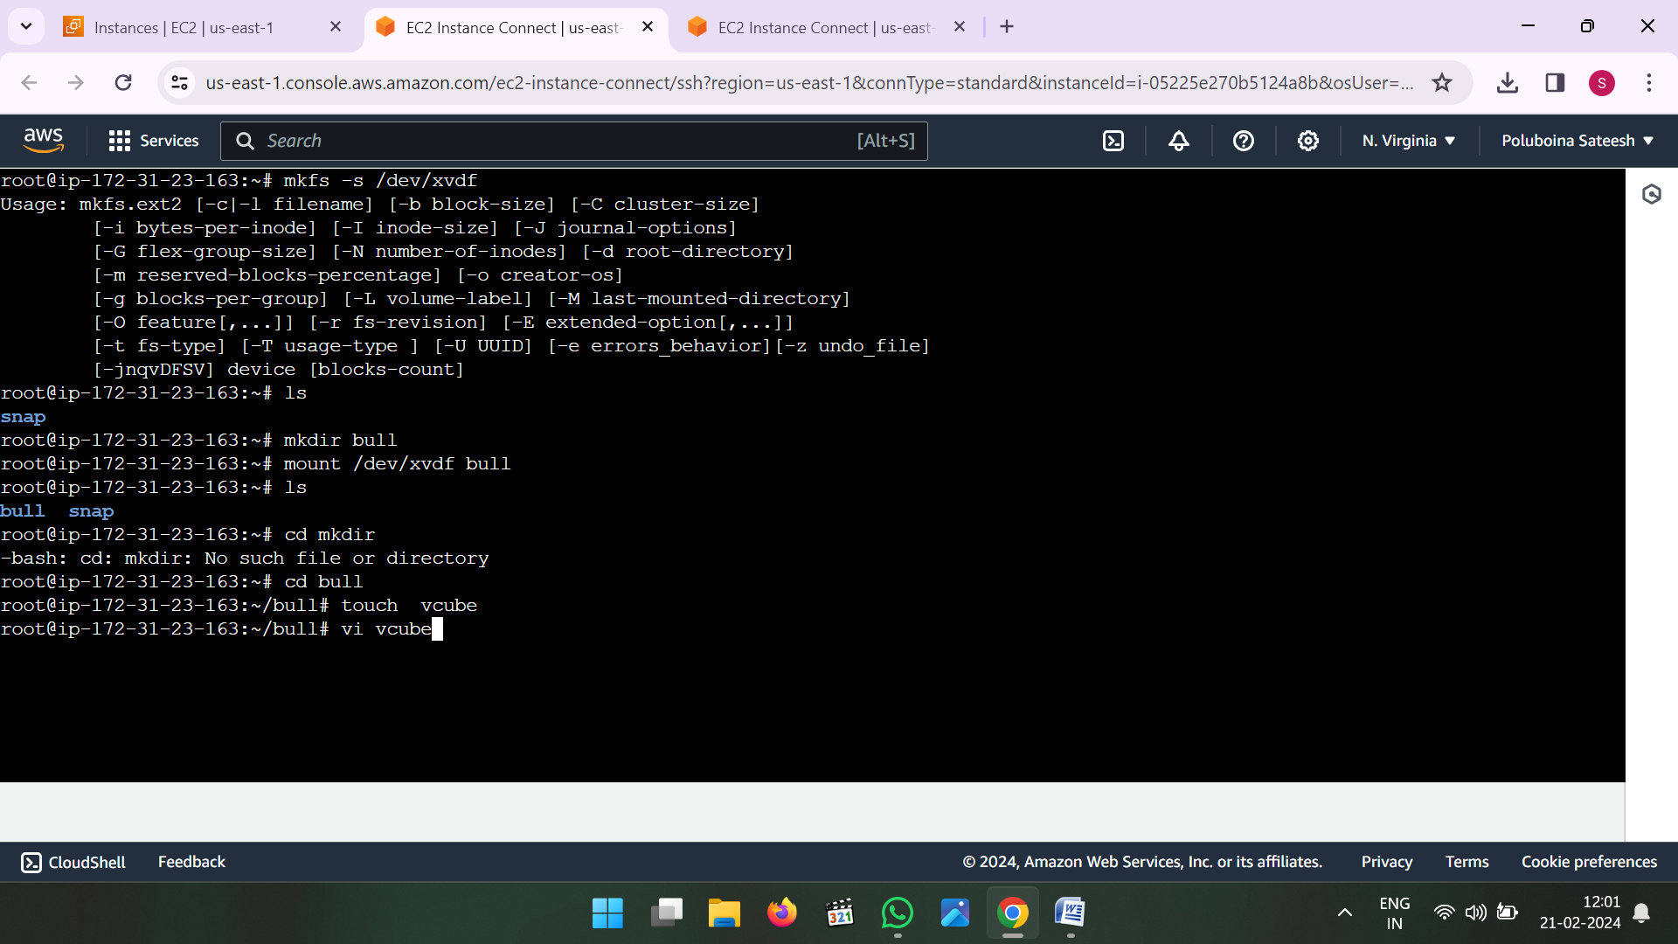

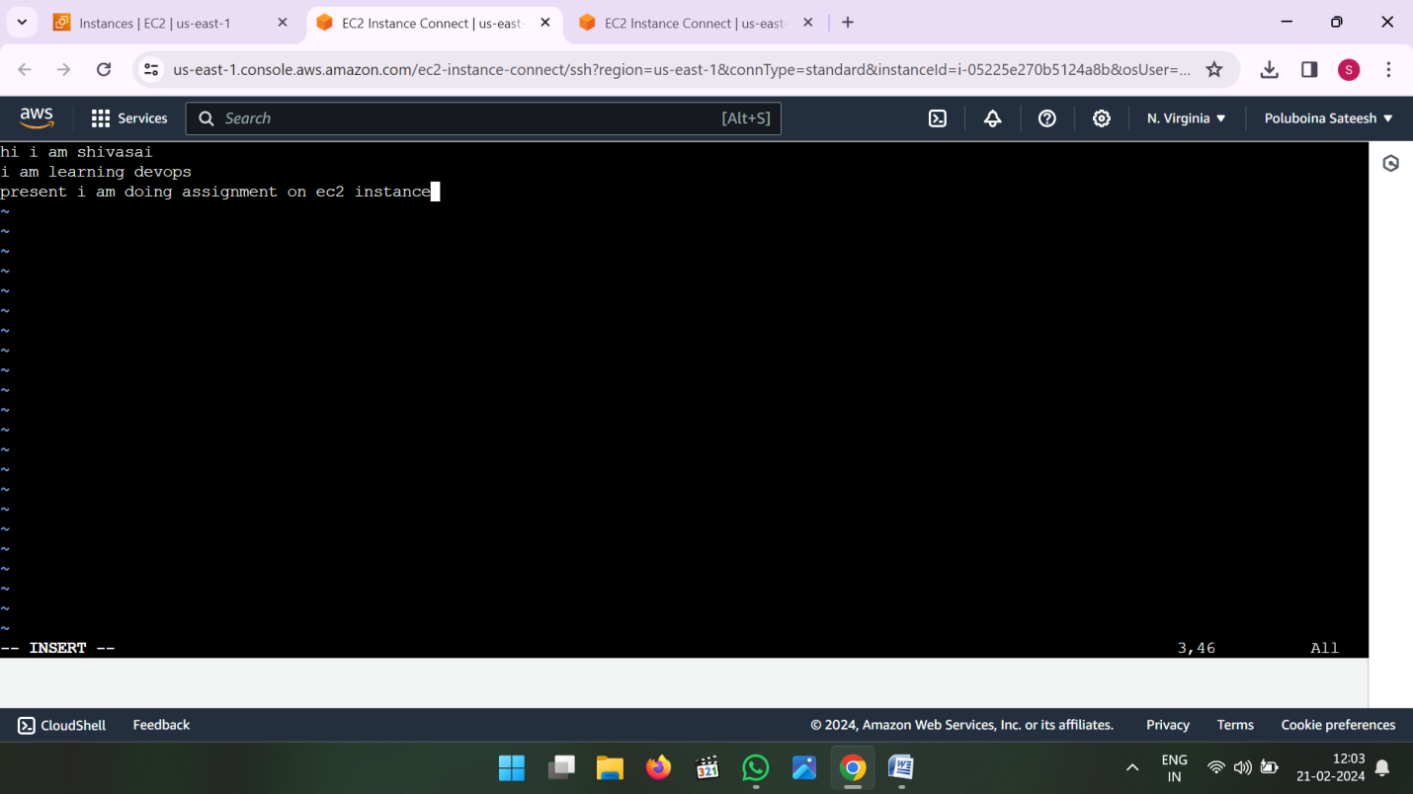

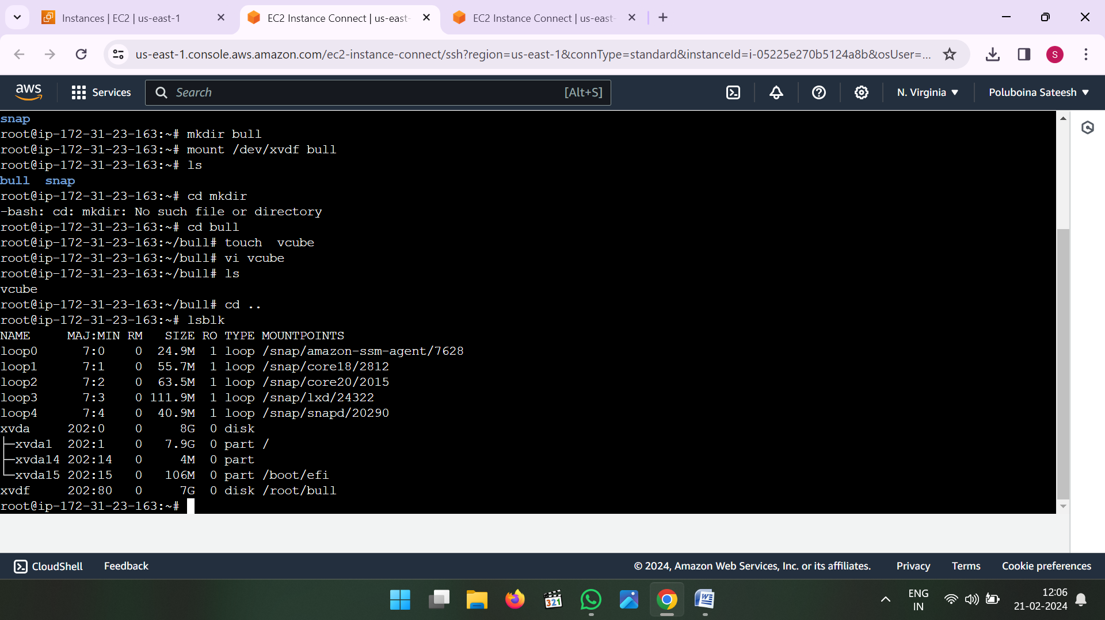

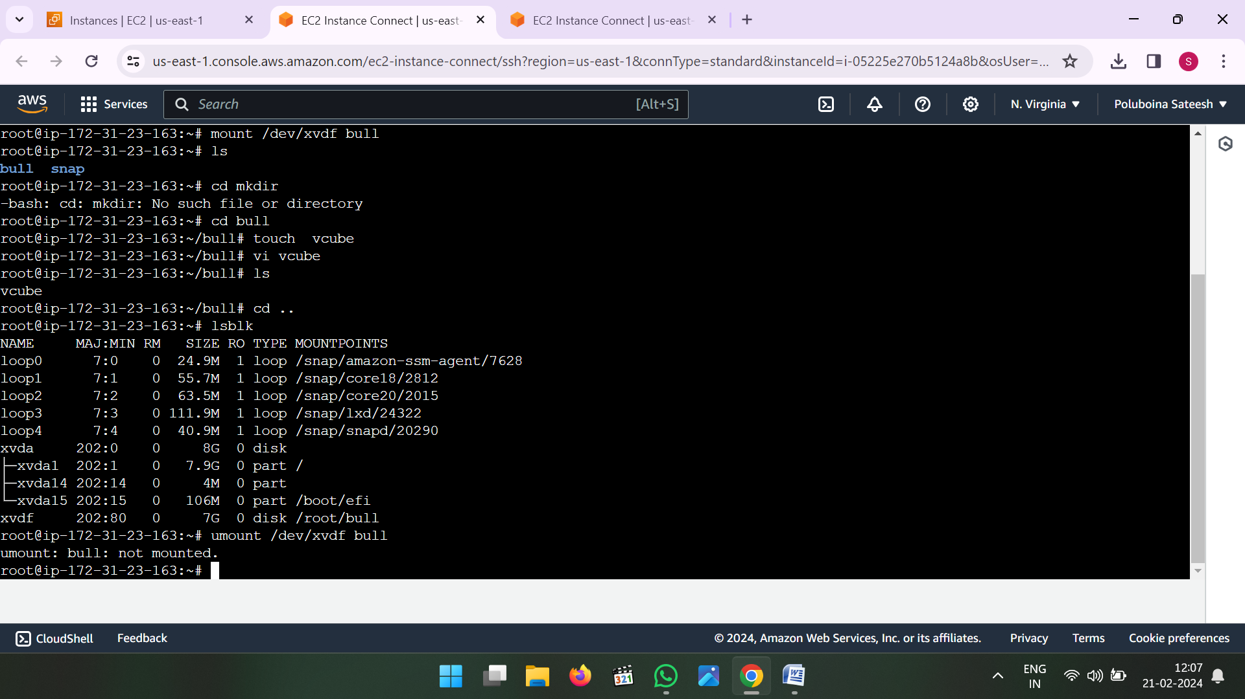

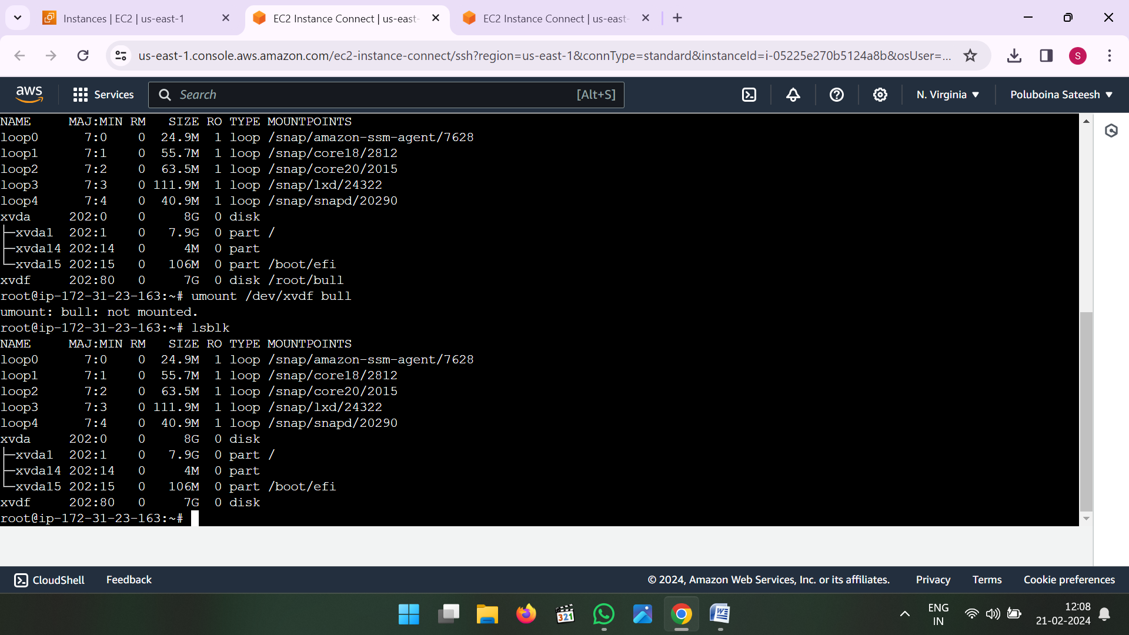

* Now go to Volumes and detach the volume to instance

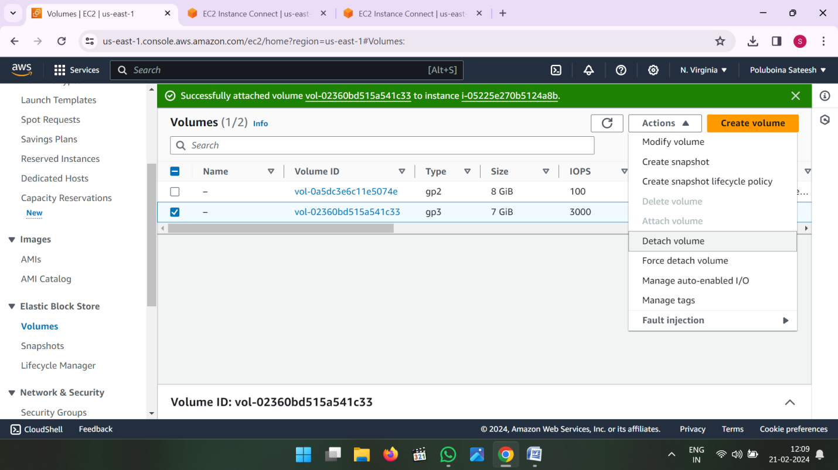

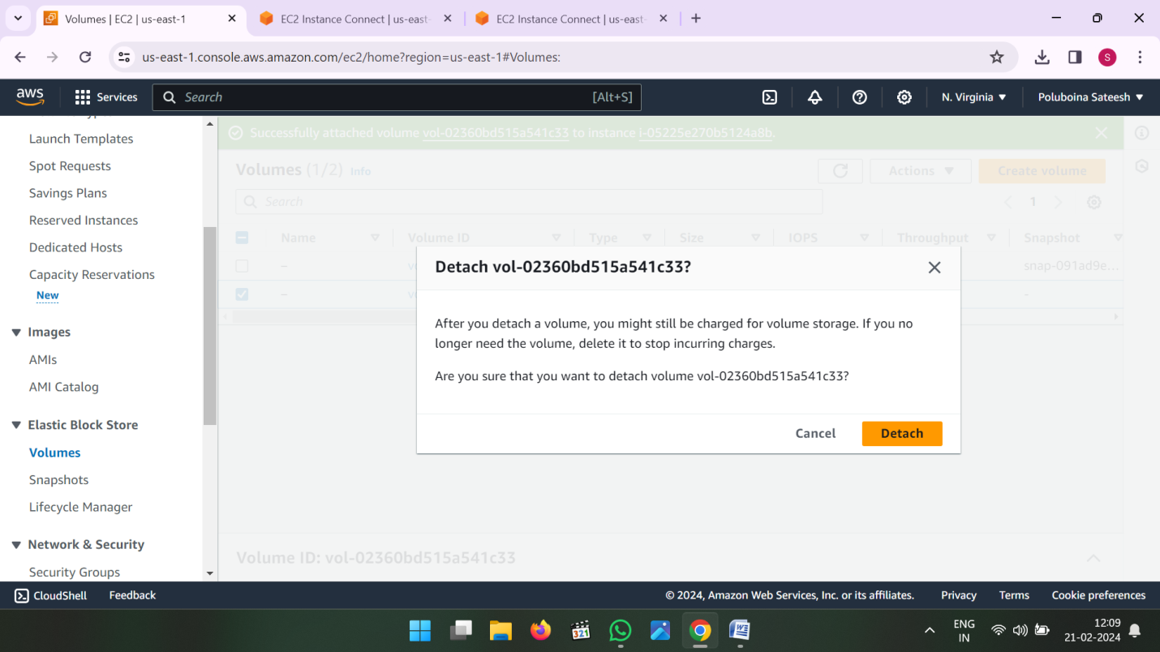

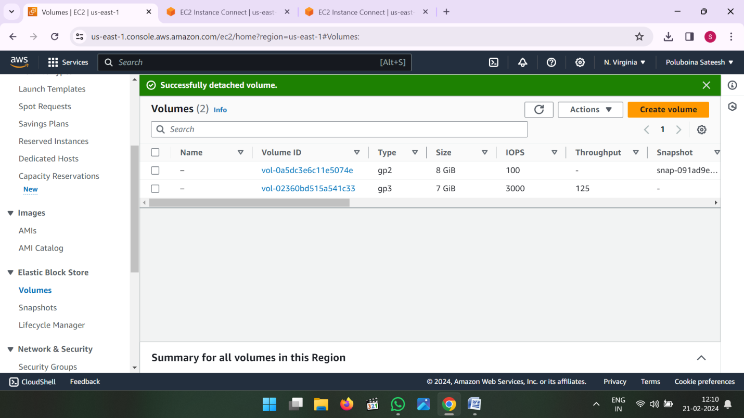

* Now to EC2 Instance and create one more instance in same availability zone

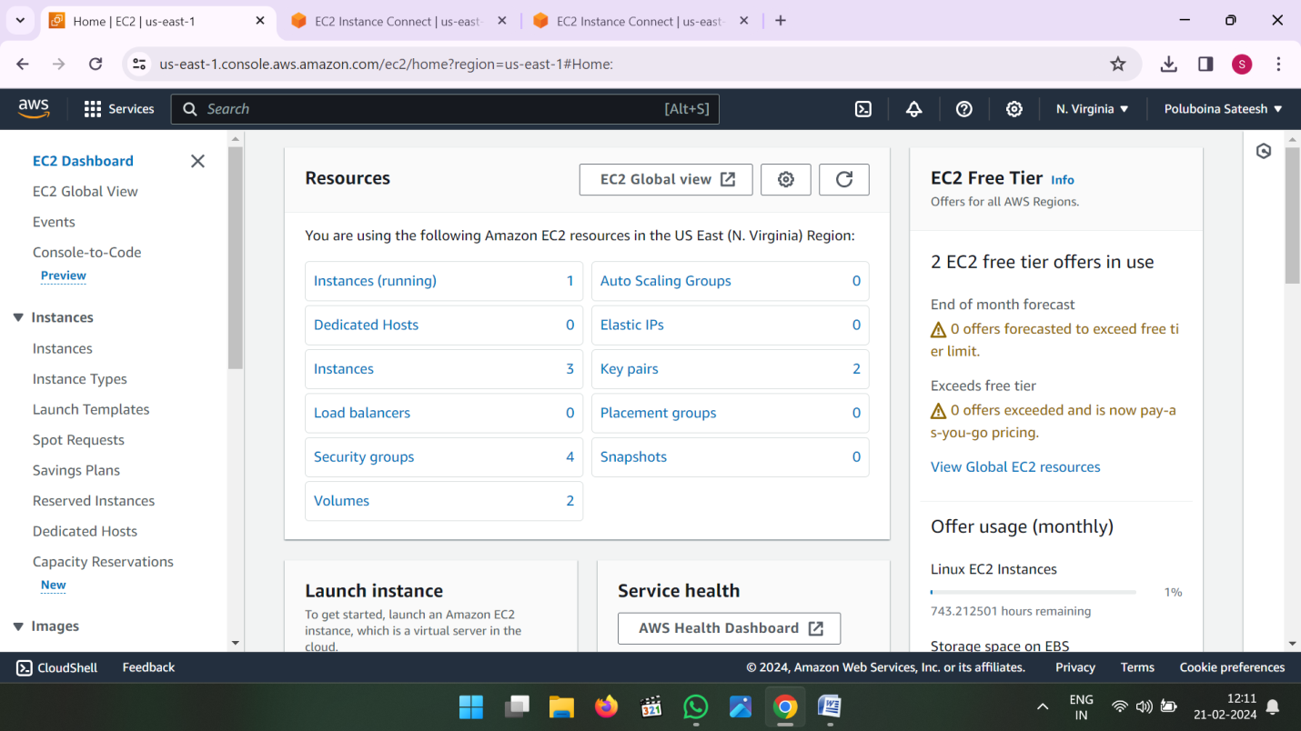

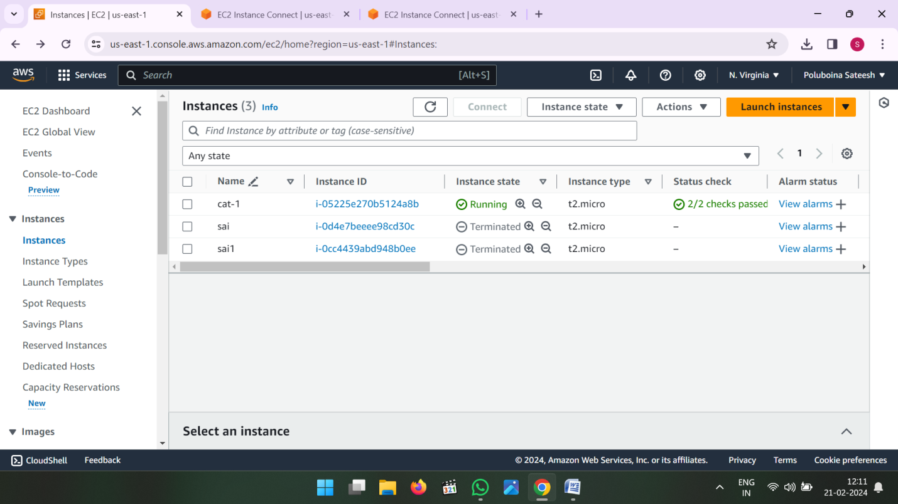

* After Creating Instance go to instance id and connect the instance

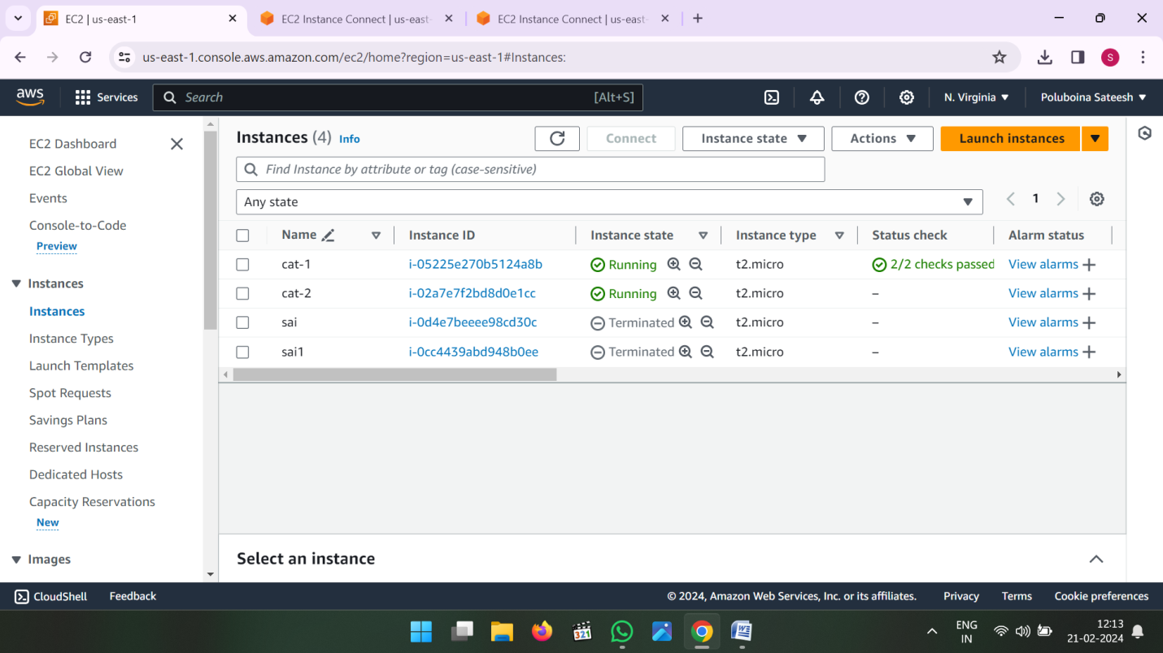

* Now go to Volumes and attach the already created volume attach to second instance

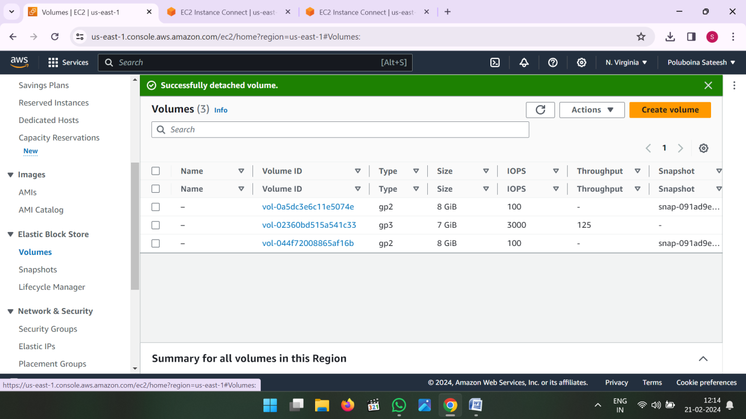

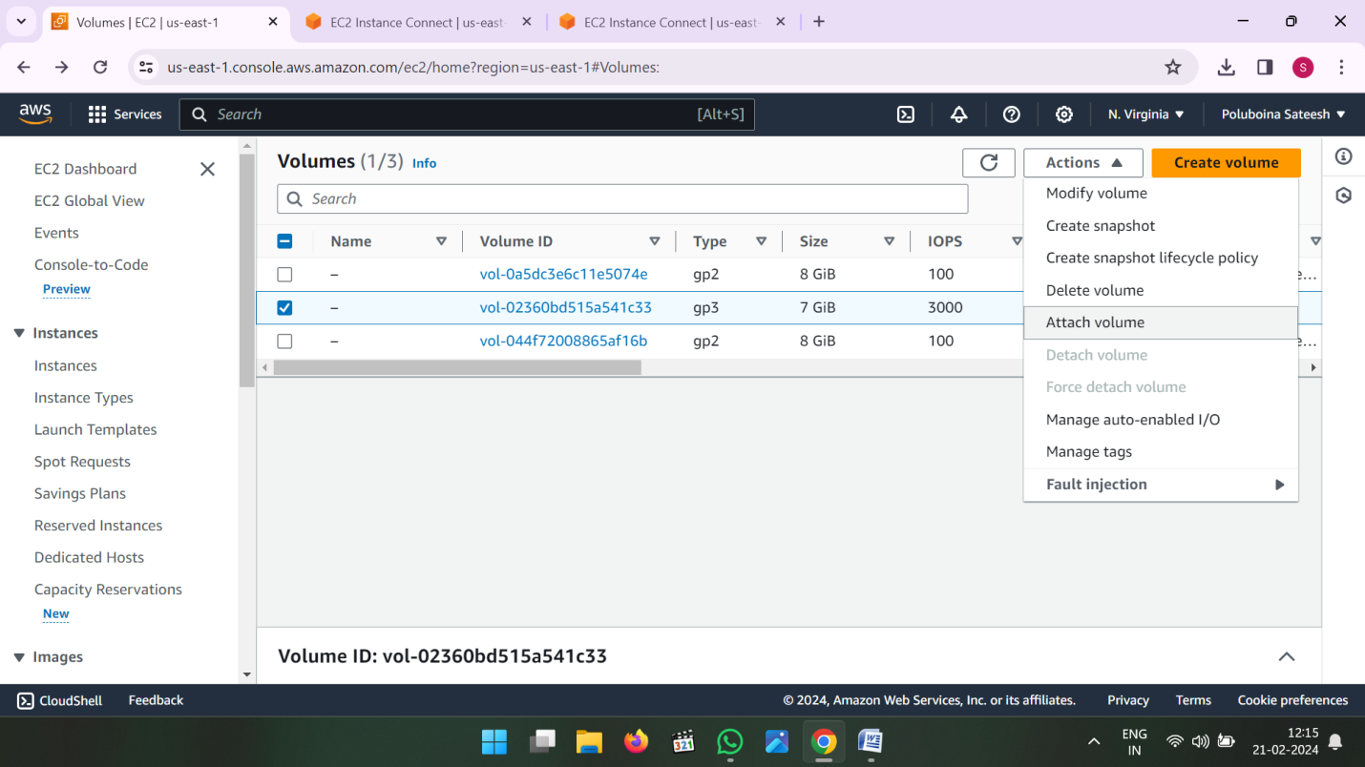

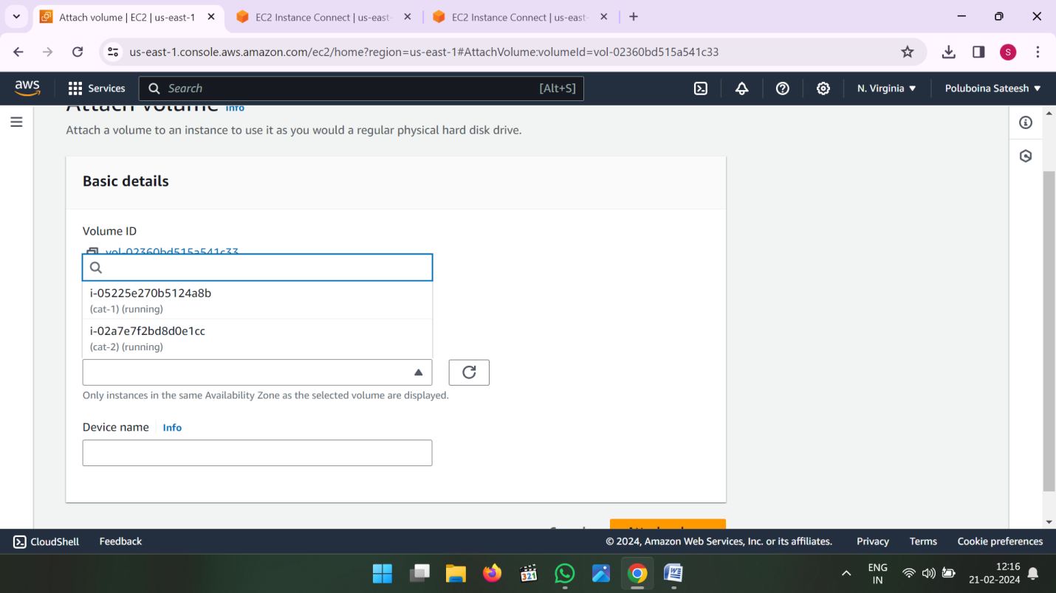

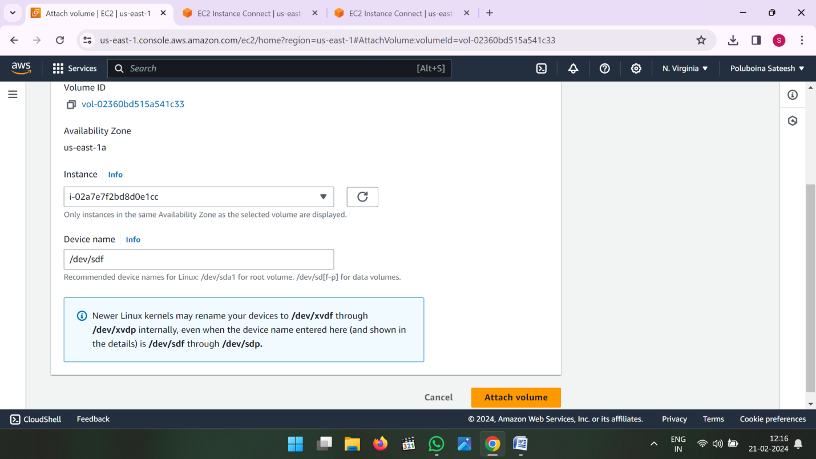

After Attach volume to check the file system is there or not

Then see the data in volume Command is

* **File –s /dev/xvdf**
* **Mkdir /data**
* **Mount /dev/xvdf /data**
* **Cd /data**
* **Ls**

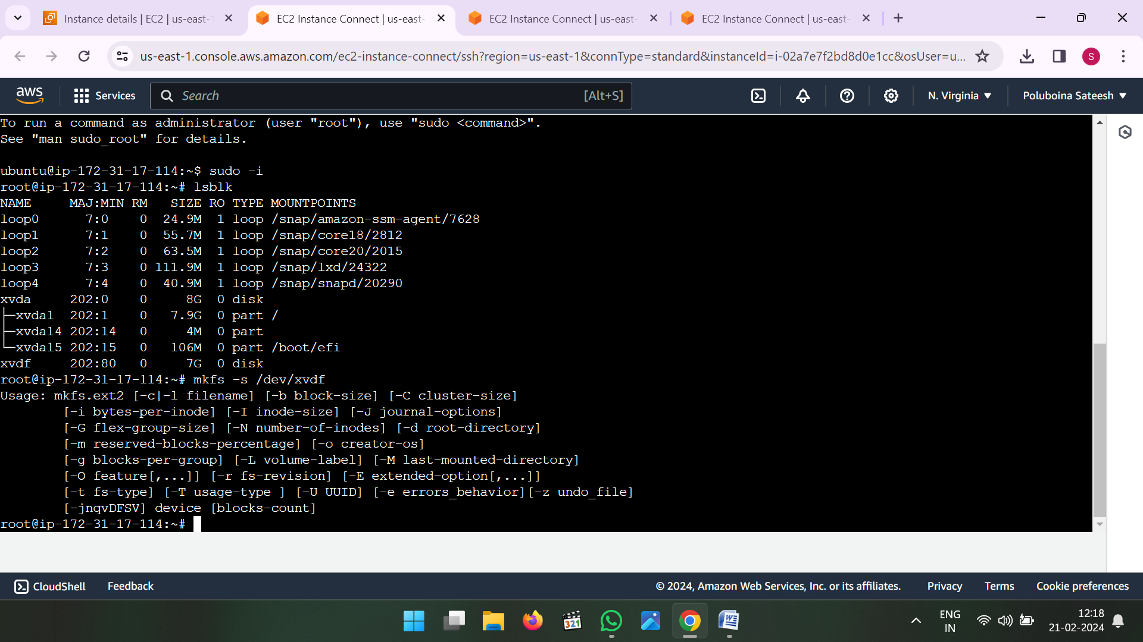

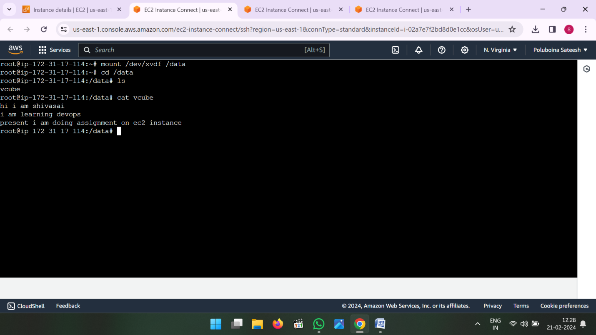

**************************** END **********************************

**V.SHIVA SAI**

**Shivasainetha313@gmail.com**

**Batch No : 120 – 5PM**

**Date : 20-02-2024.**